Conjunctions
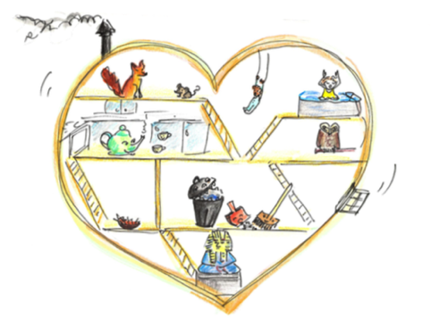
Join ideas together in your story sentences using these and other conjunctions.

and although but

since as however yet

for or

Try to use several different conjunctions in your story.

