Which Symbol?

Put in the missing symbols to make these number sentences correct.
Use + − × ÷ and =
For example:

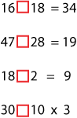
All these number sentences below, except two of them, have two solutions.
Can you find the symbols to use?
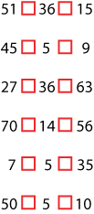
Answers
- 16 + 18 = 34
- 47 – 28 = 19
- 18 ÷ 2 = 9
- 30 = 10 X 3

- 51 – 36 = 15 OR 51 = 36 + 15
- 45 ÷ 5 = 9 OR 45 = 5 X 9
- 27 + 36 = 63
- 70 – 14 = 56 OR 70 = 14 + 5
- 7 X 5 = 35
- 50 ÷ 5 = 10 OR 50 = 5 X 10

