Egyptian Creation Story

- In the beginning the whole world was dark and there was only water, a chaos of churning, bubbling, dark water, the Egyptians called this Nun. It was out of Nun that everything began.

- Then from the depths of Nun, a hill emerged, this hill was called Ben Ben (pyramid-shaped hill).

- Then the sun-god Re (or Atum) appeared on top of Ben Ben, he was all-powerful. He could change into many forms and make things just by speaking.

- First he created the god Shu by speaking his name and gently blowing (in some versions they say he coughed him out) – Shu became the god of wind and air.

- Next Re made a wife for Shu called Tefnut - they say he ‘spat’ or ‘vomited’ her out - she then became the goddess of moisture and rain.

- Shu and Tefnut gave birth to the sky-goddess Nut and the earth-god Geb, and so the whole universe was created with Shu the wind holding up Nut the sky over Geb the earth.

- Re then took the form of a man and created many men and women over whom he ruled in the land of Egypt for many years. Many stories tell of Shu and Tefnut getting lost, & when Re found them he cried tears of joy. As his tears fell on the earth men and women were formed. Other versions explain that Re made humans from pieces of different coloured clay, which explains why there are many different skin colours.

- In time Geb and Nut gave birth to Osiris, Isis, Seth, and Nephthys and in time they became gods of the Underworld, peace, war/trouble and magic but that, as they say, is another story…

Ancient Egyptian Creation Story

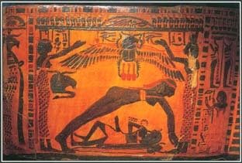

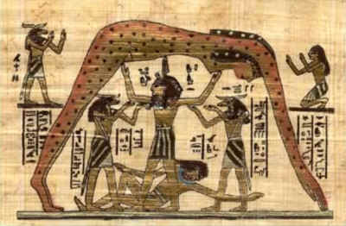

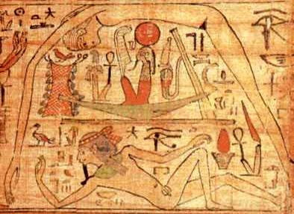

Nun | dark waters
Ben Ben | hill
Re/Atum | Sun god
Shu | god of air and wind
Tefnut | god of moisture and rain
Geb | god of Earth
Nut | god of the sky
Osiris | god of the Underworld
Isis | god of peace
Seth | god of war, trouble, evil
Nephthys | god of magic

Useful images for flow chart/family tree:

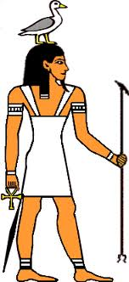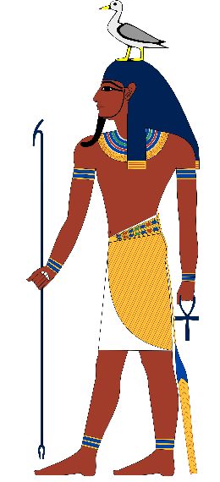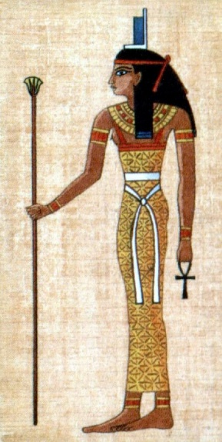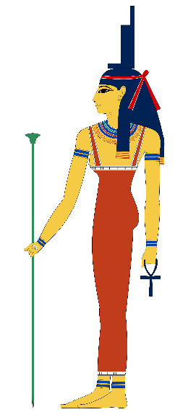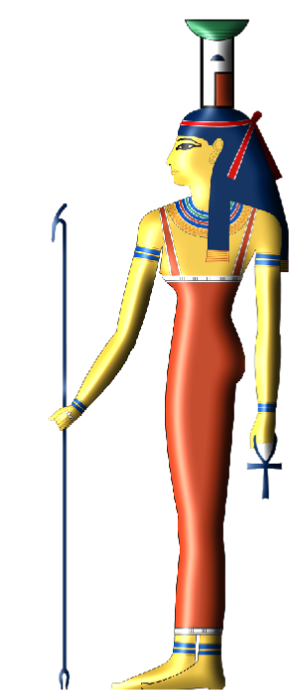
Geb Geb Isis Isis Nephthys

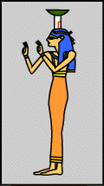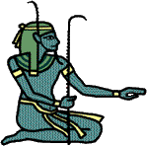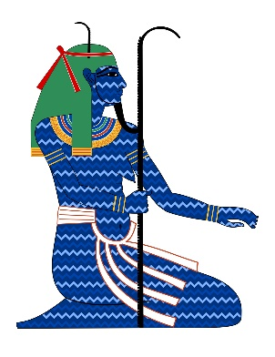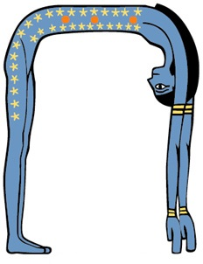
Nephthys Nun Nun Nut

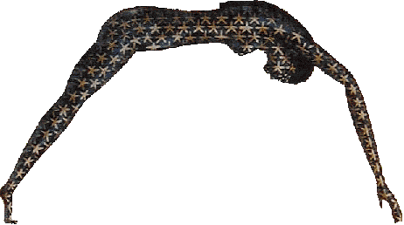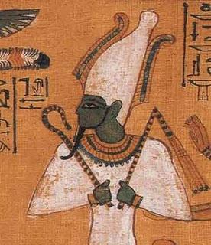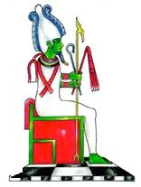
Nut Osiris Osiris

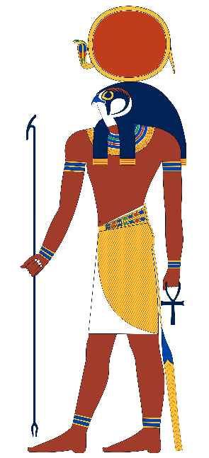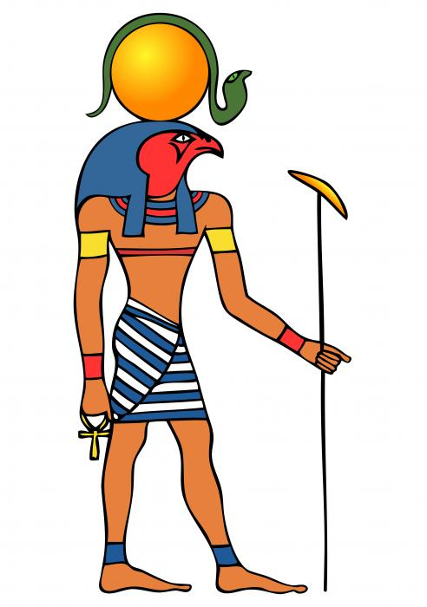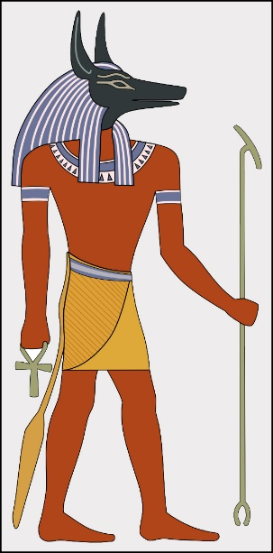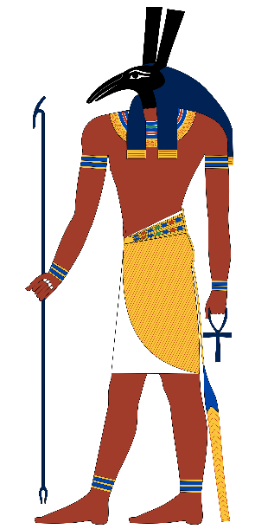
Re/Ra, Atum Re/Ra, Atum Seth Seth

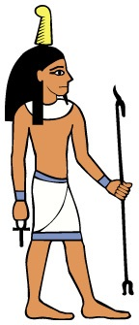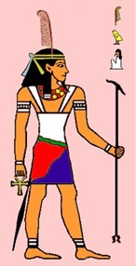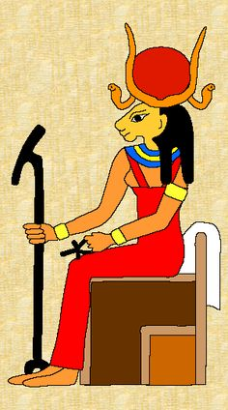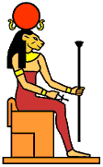
Shu Shu Tefnut Tefnut

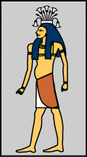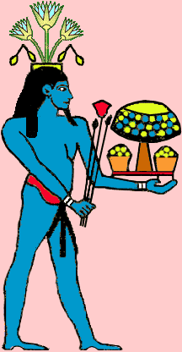
Hapi/Hapy Hapi/Hapy


