The Story of Osiris, Isis and Seth

- Osiris had become King of Egypt and was a wise, popular and successful ruler.

- Seth was very jealous of his brother Osiris because he was more important than him so he made an evil plan to kill him.

- Seth built a beautiful chest and then threw a lavish party. At the party Seth promised that whoever fitted into the chest perfectly would get to keep it. Nobody knew however that he had secretly made it the perfect size for Osiris. Everyone tried it but would not fit.

- When Osiris tried it, Seth slammed it closed and nailed it shut. He then threw it into the Nile to be swept away.

- Isis was heartbroken and immediately set off to find him. She searched far and wide. She then heard that a beautiful tree had grown on the shores of Byblos in the north and guessed, correctly that this was where the coffin had come to rest.

- Isis went to Byblos and found the coffin. There she opened it and took a last look at her beloved Osiris before looking for somewhere to bury him.

- However, Seth heard that Isis had found Orisis. He was furious and so tore up the body into fourteen pieces. Then he scattered the pieces all over Egypt so no one could restore them.

- Isis was distraught. She immediately began searching for the pieces in hopes of putting them back together. She was helped by her son Horus and her sister Nephthys also helped her.

- Eventually, they found all the parts but one, which they made a model of. They then put all the parts together and Osiris looked as he had before.

- Isis then asked Re if he could bring Osiris back to life for just one night. Re did this and then he sent Osiris to rule the Underworld, being the only person to live after death. He ruled it as he had once ruled the Earth.

- When Horus grew up he decided to take revenge on Seth for the murder of his father. After a long battle, Thoth, the god of wisdom and truth appeared.

- Thoth took both Seth and Horus to the Court of Law. They listened to Horus's side of the story and to Seth's side of the story but no one believed Seth. Seth was found guilty and sentenced to carrying the boat that held the sun across the sky for ever.

- Horus then became King and just as his father had done before him, ruled wisely and successfully over all of Egypt.

Images of additional gods:

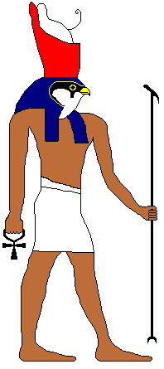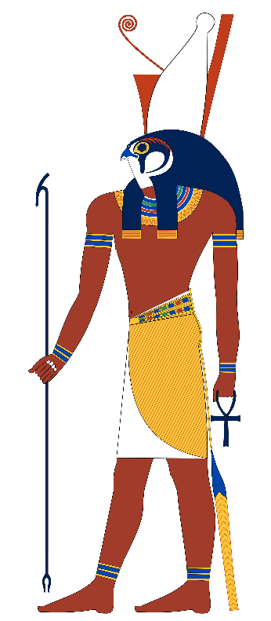
Horus

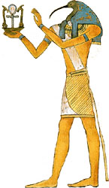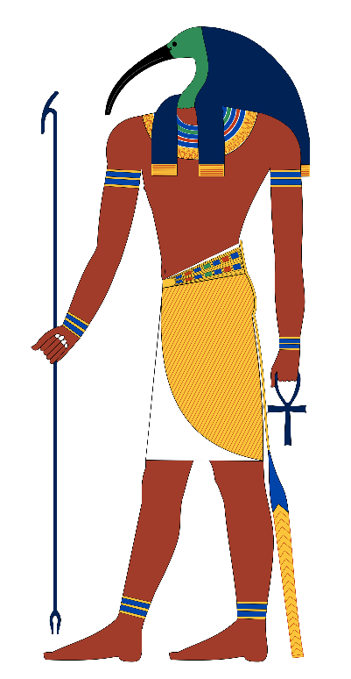
Thoth

