Can I share my understanding about the kind of world Jesus wanted for people around the world in poverty?

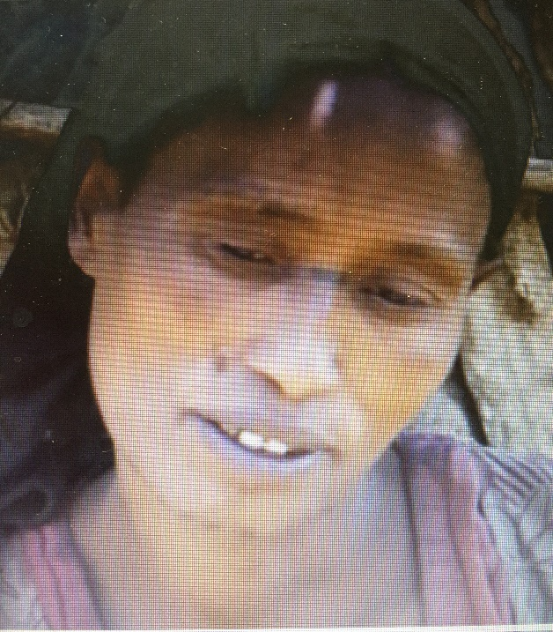

Is Workita’s life the way Jesus wanted people to live. Why?
________________________________________________________
________________________________________________________
________________________________________________________
________________________________________________________

What do you think Jesus would say to Workita?
________________________________________________________
________________________________________________________
________________________________________________________

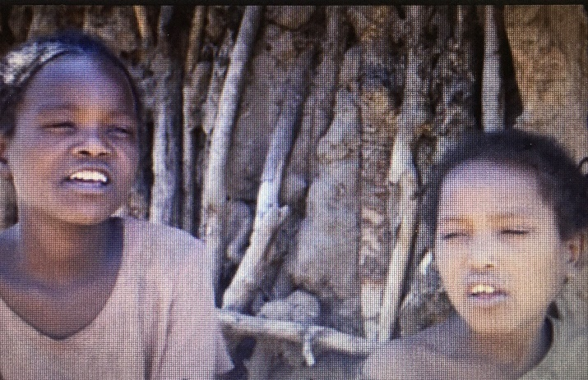
What do you think Jesus would say to Workita’s children?
________________________________________________________
________________________________________________________
________________________________________________________

What do you think Jesus would say to the person who sponsors Workita’s children?
________________________________________________________
________________________________________________________
________________________________________________________

What do you think Jesus wants Christians to do, to make people like Workita’s lives better?
________________________________________________________
________________________________________________________
________________________________________________________
________________________________________________________

