Joyeuses P$\hat{a}$ques! (Happy Easter !)
I hope that you are all having a good Easter break and are staying safe at home and importantly doing things that you enjoy. I’ve put together a group of Easter French activities for you to do if you would like to practise some French over the Easter break. Follow these instructions:

First of all, work through the PowerPoint to learn some key French Easter words. For each word, there is a sound button that looks like this:

Click on this button and press play to hear how to pronounce the word in French. Listen to and repeat the word a few times to practise pronouncing it.
You may want to write these new words down and draw pictures beside them to help you remember what they mean.
Next, you have two options. You can choose to do one of the options or both…it’s up to you!
Option 1: Make a French Easter card for someone in your family.
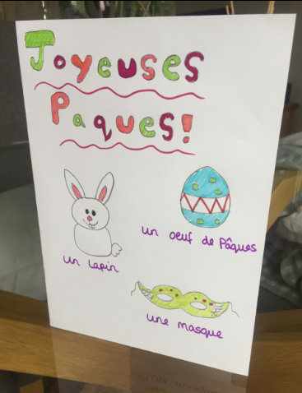
You may wish to decorate the front with Easter pictures such as Easter eggs and rabbits and label these with the French words. Here is an example of one that I have made for my brother:

When writing the message inside your card, these words might help you.
Dear = If the person you are writing to is male use ‘Cher’ or if they are female use ‘Ch$\acute{e}$re’
Happy Easter = Joyeuses P$\hat{a}$ques
Best wishes = Amitiés (In French, they don’t usually sign off their cards with ‘from’. Instead, they would use an expression such as ‘best wishes’)

For example:
Cher Ryan,
Joyeuses P$\hat{a}$ques!
Amitiés, Miss Kimber xxx

Option 2: Record a ‘Joyeuses P$\hat{a}$ques’ video message for someone you care about and send it to them online.
You could use a phone, tablet or computer to record yourself saying ‘Joyeuses P$\hat{a}$ques’ to a friend or family member. Don’t forget to tell them what this means in English otherwise they might not understand what you are saying! Ask an adult at home for help to send this on to them.

