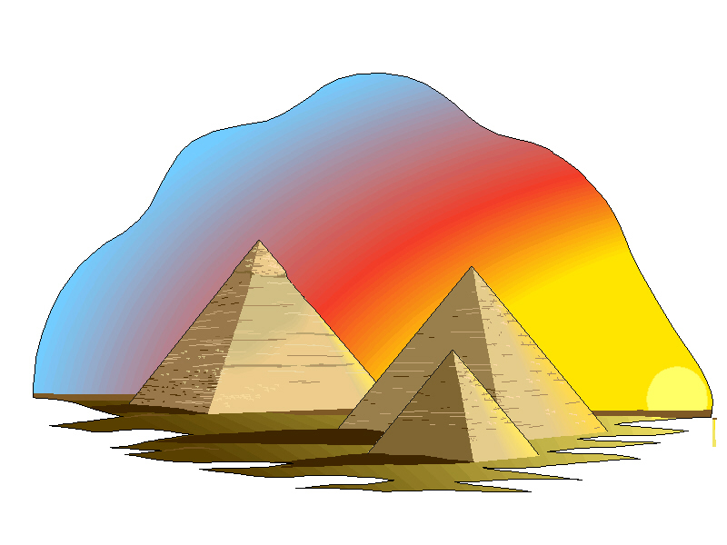
By Charlotte Gordon
Pyramid Poem
Pyramids golden Left and right As tall as a giant
But dark inside. Corridors that lead different ways. Made of limestone.
Traps lay about These Pyramids so old Pharaohs are buried here
So no one can hide. They’ve been there for many days. A Sarcophagus as their throne.

