The Nile
By Connor Collins

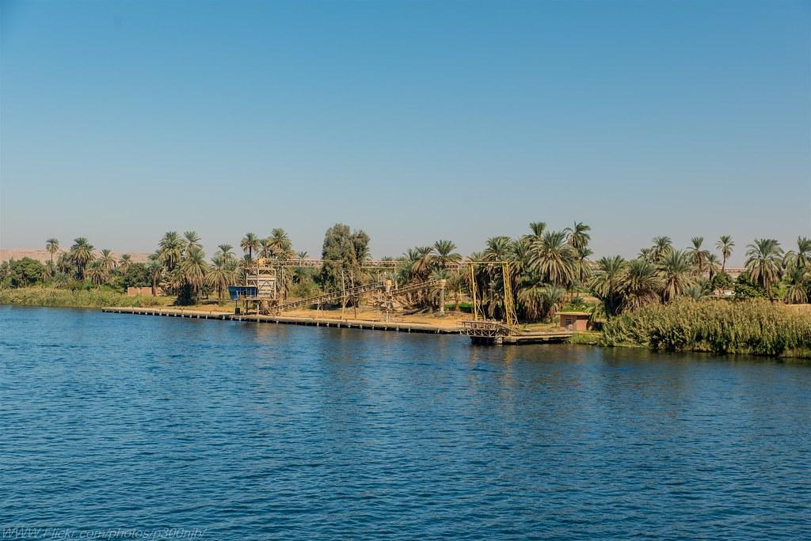

Travel
The ancient Egyptians travelled by boat of course! Because there was no point building roads because the Nile flooded every year and they'd be washed away .

Boats
There were lots of boats in Egypt, big luxury ones for pharaohs and fishing boats made out of papyrus reeds, which is also what they used for paper. There were wooden cargo ships full of pyramid blocks and passenger boats overloaded with people.

Seasons
There were three seasons:

- Akhet the flooding season there was no farming at this time
- Peret growing season
- Shemu harvest .

Farming
Farmers dug channels for the crops to grow shadufs were used to move water.
Did you no that is the longest river in the world at 6,853



