River Nile Facts
By Austen
Useful facts
The River Nile is the longest river in the world. It is at least 6670km long. The Nile is at least 30 million years old. The Nile runs through Tanzania, Uganda, Rwanda, Burundi, The Democratic Republic of Congo, Kenya, Ethiopia, Eritrea, South Sudan, Sudan and Egypt.
Did you know?
Hippos live in the Nile reeds and Egyptian men used to hunt them to show off their courage.
Natural Materials
When the Nile flooded, it left mud that the Egyptians made into bricks.
The Nile was a good environment for papyrus reeds. The papyrus reeds were used by the Egyptians to make paper.
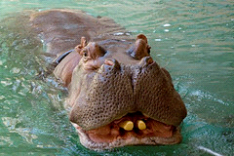
Food Supply
The Nile used to flood every summer. After the flood, fertile, thick and black mud appears. The Egyptians grew their crops in it so they could eat. The only source of water was the Nile. Without the Nile the Egyptians would be dead.
Transportation
One way of transportation was boats. All sorts of boats like fishing boats, cargo boats and funeral barges were used. The rich had luxurious boats.


