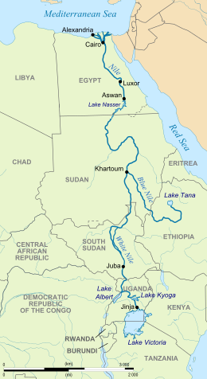
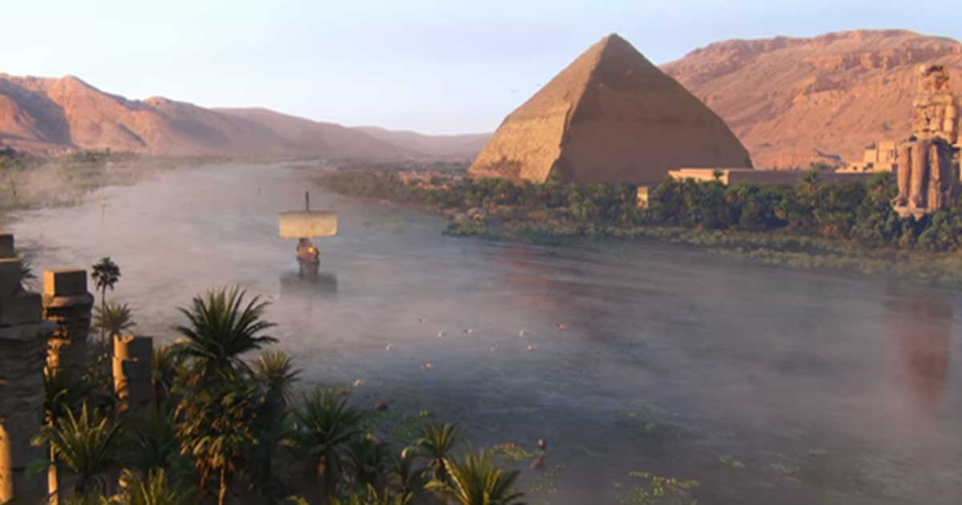

The river Nile is located in the North East of Africa and runs through 11 countries.
The Ancient Egyptians used the river Nile as a road for travelling and a water source for their crops.
There are two other rivers called the blue Nile and the white Nile that originate at lake Victoria and lake Tana. These rivers meet in Sudan to form the river Nile and continue their long journey north towards the sea.
The Egyptians knew the time of year when the Nile would flood, so they depended on it to bring extra water and rich soil for their crops.
The river helped the Ancient Egyptians build pyramids because they could transport everything they needed on a boat.

Did you know?
The river Nile is the longest river in the world and has a length of 4,160 miles!


