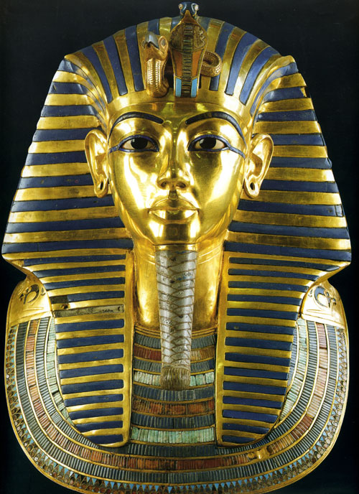

Tutankhamun's gold death mask is probably the most famous artefact ever found in Egypt. Howard Carter described it as: 'a beautiful and unique specimen of ancient portraiture', which 'bears a sad but calm expression suggestive of youth prematurely overtaken by death.'

The mask is a marvel of skilled craftsmanship. Weighing 10kg, it was beaten from sheet gold and inlaid with coloured glass and semi-precious stones. The stripes on the headdress are glass, but the eyeliner and eyebrows are of lapis lazuli, one of the Egyptians' favourite stones, which had to be imported from Afghanistan. The eyes themselves are of obsidian (black volcanic glass) and quartz.

Tutankhamun wears on his forehead two goddesses - Nekhbet, the vulture goddess of Upper Egypt, and Wadjet, the cobra goddess of Lower Egypt - protecting him, and showing that he is ruler of both kingdoms. On his chin is the false beard worn by pharaohs on important occasions.

Over his shoulders Tutankhamun wears a collar, of lapis lazuli, quartz and green feldspar, with a lotus-bud border. On each end are falcon heads, representing Horus, god of pharaohs.

The holes in the ears show that Tutankhamun, like many young Egyptian boys, wore earrings. By adulthood he would have stopped wearing them.

