Questions about The Night Shimmy

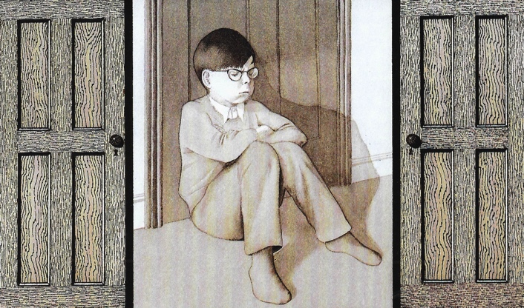

1. Who do you think the Night Shimmy is? Tick one of the options below or add your own answer.

A real friend of Eric’s _____________________________________________
A visiting wizard ________________________________________________
A superhero like Batman or Superman _________________________________
Eric himself imagining that he is the Night Shimmy ________________________
An imaginary friend of Eric’s ________________________________________

2. Explain why you think that.

______________________________________________________________________________________________________________________________________________

3. What sort of things does the Night Shimmy do for Eric? Mention at least three things.

_____________________________________________________________________________________________________________________________________________________________________________________________________________________

4. Why do you think the Night Shimmy disappears at the end of the story?

______________________________________________________________________________________________________________________________________________
_______________________________________________________________________

5. When does the parrot first appear in the story?

_______________________________________________________________________

6. When does it become real?

_______________________________________________________________________

7. How many parrots are there on the page which begins, ‘They began to talk.’?

_______________________________________________________________________

8. What do you think the parrot suggests about how Eric is feeling at the end of the story?

______________________________________________________________________

9. Look at the page, ‘Eric slammed his bedroom door shut...’ Why do you think Anthony Browne has drawn the picture just in greys and browns?

______________________________________________________________________________________________________________________________________________

10. With most of the pictures in the book, it is a bit like we are looking through a window that is surrounded by black. How are the last three pages different?

_______________________________________________________________________

11. Why do you think are they different?

_____________________________________________________________________________________________________________________________________________________________________________________________________________________

