Expanded Noun Phrases

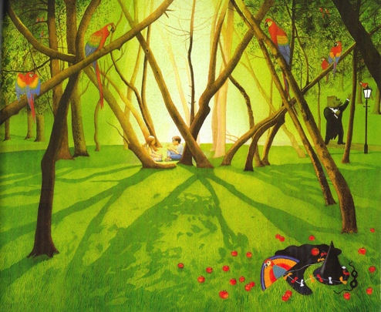

These are examples of noun phrases.

the park a kite some trees two children

If we want to describe the nouns (the objects or things or people) in these phrases in more detail we can expand the phrases.

We do it like this:

1. Add some adjectives to tell us more about the noun.

the big park a bright, cheerful kite some tall, thin trees two happy children

If we use two adjectives we usually separate them with a comma.

2. Modify the adjective with adverbs. The adverbs tell you more about the adjectives.

the really big park a very bright, cheerful kite some extremely tall, thin trees two rather happy children

3. Add a prepositional phrase. The prepositional phrase tells you a bit more about where or when things happen or how things relate to one another.

the really big park with a singing gorilla
a very bright, cheerful kite beside the path
some extremely tall, thin trees on top of the hill
two rather happy children before bedtime

