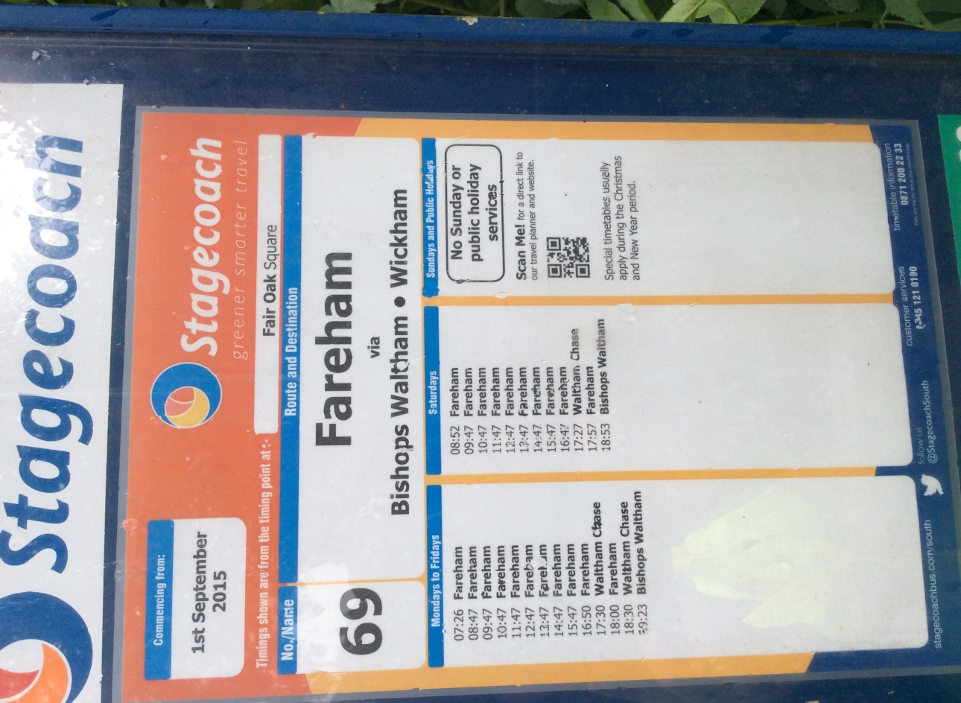
Upham village bus stop
How many buses go from Upham to Fareham on weekdays?

If you arrive at the bus stop at 07:20 on Tuesday how long will you have to wait for the next bus?

What time does the last bus leave for Fareham on Saturday?

If it takes 10 minutes to walk to the bus stop, what time do you need to leave to catch the 17.30 bus?

On Saturday which is the earliest bus to Fareham?

How long after the 16.47 Saturday bus do you have to wait for the next bus?

Write 2 more of your own questions using the timetable. If you would like to, you could email these to a friend in the class to answer. Remember to work out the answers as well!

