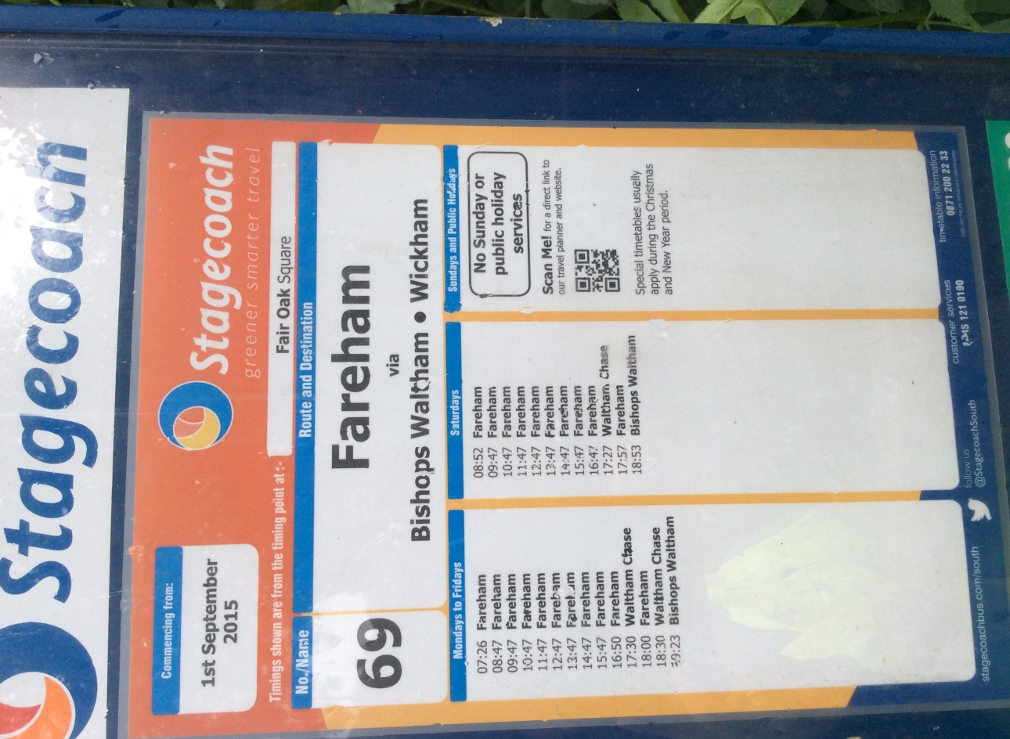
Upham village bus stop
It takes 20 minutes to walk to the bus stop. What time would I need to leave by to catch last bus to Bishops Waltham on a Saturday?

Write 2 more questions using the timetable. (remember to work out the answer too!)
If you can, you could email them to one of your friends in the class to answer.

How many buses go from Upham to Fareham on weekdays?

If you arrive at the bus stop at 09:30 on Tuesday how long will you have to wait for the next bus?

What time does the last bus leave for Fareham on Saturday?

If you miss the first bus on Thursday by 10 minutes, how long until the next bus?

