Robbie buys a bag for £28, a guitar for £125 and music for £19. He has saved £20 per month for one year. How much money will he have left?
8 friends pay to go swimming. The tickets cost £4.50 each. The girls spend £13.50. How many boys went swimming?
Fran, George and Simon count their stickers. They have 3500 in total. Fran has 1210, George has 325 less than Fran. How many does Simon have?
A school is organising a trip. There are 145 children and 18 teachers. A minibus can carry 10 people. How many will be needed?

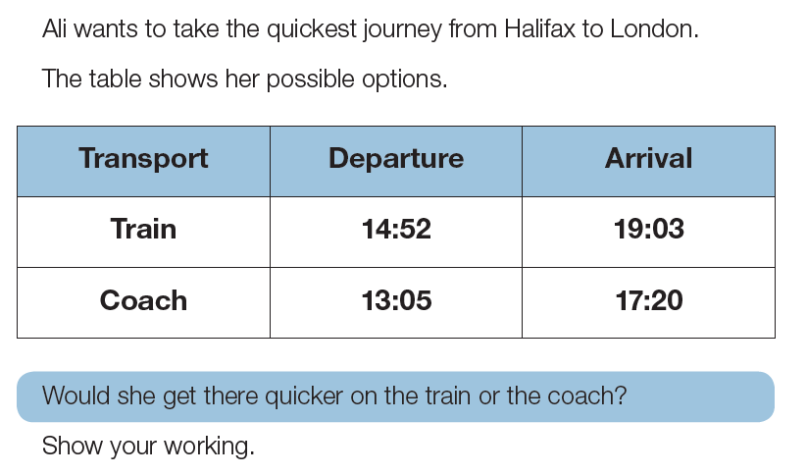
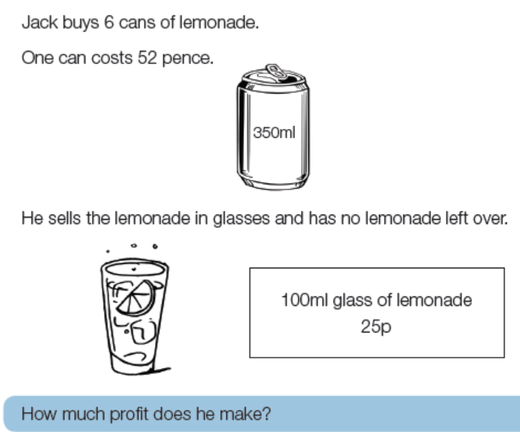

Challenge: How many different ways can you solve the missing number problem?
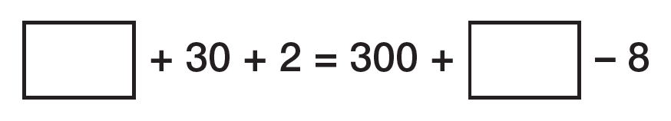
Robbie buys a bag for £28, a guitar for £125 and music for £19. He has saved £20 per month for one year. How much money will he have left?
£68
8 friends pay to go swimming. The tickets cost £4.50 each. The girls spend £13.50. How many boys went swimming?
5
Fran, George and Simon count their stickers. They have 3500 in total. Fran has 1210, George has 325 less than Fran. How many does Simon have?
1405
A school is organising a trip. There are 145 children and 18 teachers. A minibus can carry 10 people. How many will be needed?
17
Train took 4hours 11 minutes. Coach 4 hours 15 minutes so train is quicker
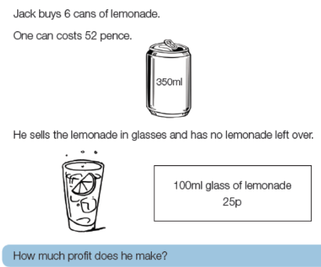

£2.13

Challenge: How many different ways can you solve the missing number problem?
Many different solutions are possible. One solution is 300+30+2= 300+40-8

