Look after your world
Why you shouldn’t use plastic.
You shouldn’t use plastic because it takes too long to degrade away on landfills and if you burn it, it gives of fumes that cause climate change.
Also, it doesn’t degrade, it makes micro plastics that kill animals if they eat them.

Make sure you recycle.
If you don’t recycle, you will be using up planet resources and if you do recycles you will be saving a lot of energy and you will be reducing pollution.

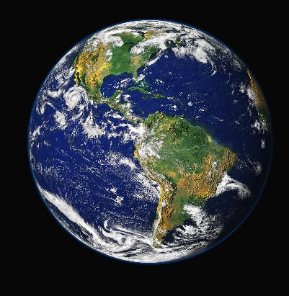
Stay Local.
1. Use local produce.
2. Eat seasonal produce.
3. Don’t fly to different countries as much.
4. Try to go to places where you can walk instead of using your car.


