Hello Everyone,
I hope you all had a good week last week and then had a good rest from work over the weekend. I did try to join in with the Jo Wick’s exercises but they were a bit too energetic and fast for me! Then I looked at PE Dave’s sit- ups challenge; I can’t remember the last time I did a sit-up but, to my amazement, I managed……….one! Every day, I am aiming to do one more. So maybe by the time we are back at school again, I will have tight tummy muscles, too.
Last week, I completed my “wicker basket” project: I took out the filthy old lining, scrubbed the basket and then lined it with bright new oilcloth and filled it with my garden seat cushions. I also cleared the fruit cage of brambles and dug it over. It was hard work but it kept me fit. This week, I am tidying all the seed trays and plant pots and repotting some geraniums in the greenhouse.(It’s lovely and warm in there!) Mr. Kimble is painting the extension wall. Next week I will weed some flower beds and I will bake a Simnel cake.
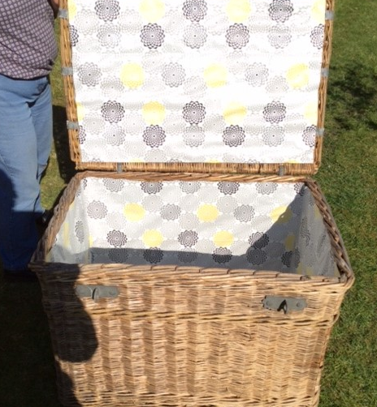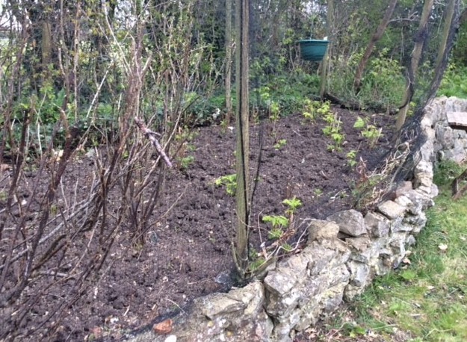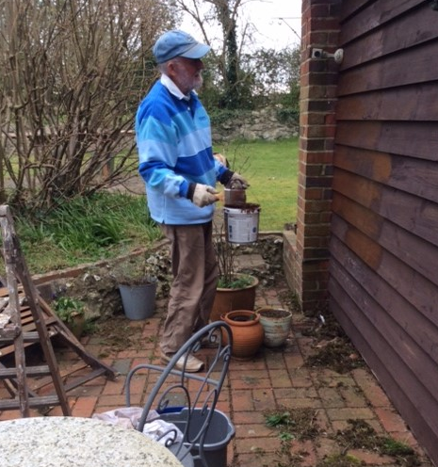

Now, let’s start with some Refreshing SPAG Stretches.
In that little piece of my journal above you will see that some words are in bold. Have a good look at them. What word class do they belong to? What is the grammatical name for those kinds of words?
Yes, they are VERBS. They are “doing words” which tell our readers about actions.
Can you find more VERBS in my first paragraph? Perhaps you could write them down.

Energetic SPAG Stretches
What is the verb in the following sentence:
Mrs. Kimble dug the flower bed.
Yes, it is dug.
It was hard work and sometimes, I enjoyed it and sometimes, I didn’t really want to carry on and sometimes, I felt very tired.
Can you think of single words – adverbs – I could use at the beginning of the sentence to show how I felt at different times and how I was digging?
I’ll start you off with some examples:
Enthusiastically, Mrs. Kimble dug the fruit bed.
Sulkily, Mrs. Kimble dug the fruit bed.
Make a list of all the adverbs you can think of to start my sentence to show how I felt about what I was doing.
Handy hint. Does this fit in with your spelling sentences?
Finally some Extended Stretches
Last week , I completed my “wicker basket” project. I did this in the past.
Today, I am tidying the plant pots. I am doing this in the present.
Next week, I will bake a Simnel cake. I will do this in the future.
The verbs in each of these sentences are in a different tense: Past, Present and Future.
Can you write three sentences, one in the past tense, one in the present tense and one in the future tense, telling me what you did last week, what you are doing this week and what you will do next week.? Perhaps you could send them to Miss Olver and she could send them on to me.
I’ll finish with a smile. One of my groups sent me this joke a few years ago.
Past, Present and Future walked into a bar………….it was tense.

Enjoy the rest of the week,
Love from Mrs. Kimble.

