Hello Class 4. I hope you are all looking after yourselves and your families and are enjoying your home learning. I also hope that you’ve been enjoying some time outdoors and doing things that you enjoy during your breaks and at the weekend. I’ve been spring cleaning, playing games with my family, going outdoors for runs and of course cuddling my cats!
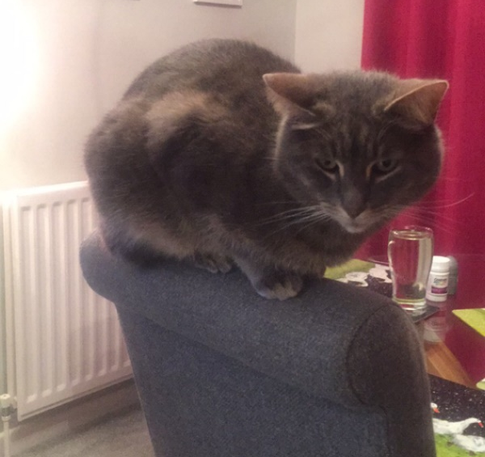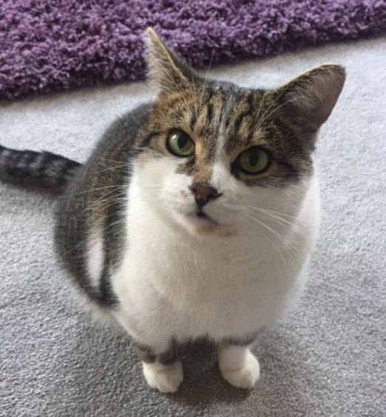
Max Harry

I’ve put together a French lesson for you to do at home. I know how much you all enjoy learning French at school so I’m hoping you’ll be excited and eager to do some at home too! You are going to have to think back to the French vocabulary we learnt about instruments to help you.
Start by translating all of these French instrument words into English in your book and draw a picture for each:

le piano
le violon
le saxophone
le cors
la fl$\hat{u}$te
la guitare
la batterie
la trompette
la clarinette

Check your translations using the ‘French instruments vocabulary answer sheet’

Here are 2 new words for you to learn:
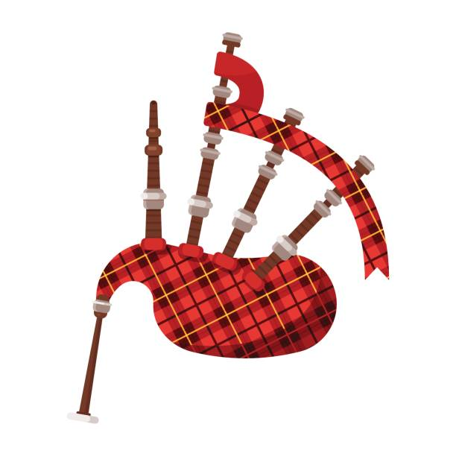Le biniou (the bagpipe)
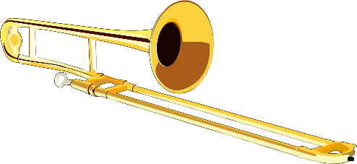 Le trombone (the trombone)
Listen to how each word is pronounced in French and have a go repeating it lots of times. Can you think of good actions to go with them?

Write down these translations into your book also.

Next, I would like you to listen to and join in on this French version of ‘I am The Music Man’. As well as some fantastic French, it has some great dance moves so get up out of your chair and join in with the dancing! Perhaps you could practise it a few times and then either perform it to someone at home or record yourself having a go! You could also add extra verses, using your knowledge of different instruments.
This is the link to the song:
https://www.youtube.com/watch?v=qGzH_lisPXg

Here are the words to the song:
Je suis le musician (I am the musician)
J’aime la musique (I like music)
et je joue… (and I play…)
du piano (some piano)

Je suis le musicien ( I am the musician)
J’aime la musique (I like music)
et je joue… (and I play…)
du trombone (some trombone)
Piano (piano)

Je suis le musicien (I am the musician)
J’aime la musique (I like music)
et je joue… (and I play…)
du biniou (some bagpipe)
Trombone (trombone)
Piano (piano)

Je suis le musicien (I am the musician)
J’aime la musique (I like music)
et je joue… (and I play…)
de la trompette (some trumpet)
Biniou (bagpipe)
Trombone (trombone)
Piano (piano)

Je suis le musicien (I am the musician)

