Easter cards
You will need:
Colour card/paper
Glue
Colouring pens
Scissors
Pen/pencil
Rubber
A way to see YouTube video (KROKOTAK – Easter cards) It’s the second one in the list.
Coffee is optional!

I particularly liked the chicks so had to make one of those.
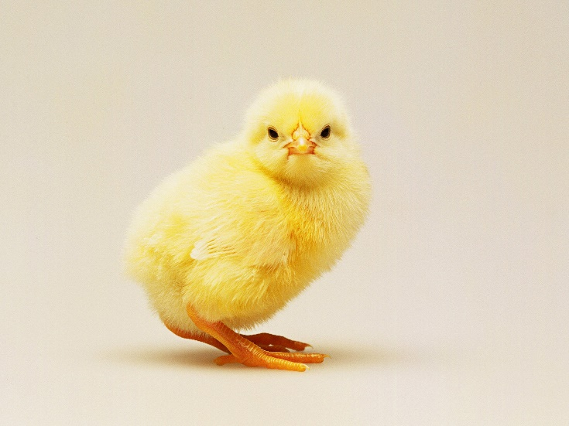

As you can see, there are lots of ideas on this site. Perhaps you could make something else and send us a photo of your crafting? Who doesn’t love a bit of cutting and sticking?
HAPPY CRAFTING

https://www.youtube.com/watch?v=s_gwArY5qNs

