Greek Problems

- On Friday, Mrs Soley shared a recipe with you to make Greek meatballs. The recipe said it would make 20 meatballs and the ingredients included:
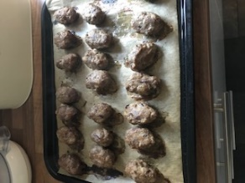
250g minced beef
100g minced pork
½ onion
75g breadcrumbs

- If I wanted to make 40 meatballs, how much of each ingredient would I need?
- If I wanted to make 10 meatballs, how much of each ingredient would I need?
- If I had a party and wanted to make 100 meatballs, how much of ingredient would I need? Can you think of more than one way to solve part c)?

- In each city-state, approximately one third of the citizens were slaves.
- Write down three fractions which are equivalent to one third.
- If there were 3000 people in the city-state, how many citizens would have been slaves? How many would not have been slaves?
- If there were 600 people in the city-state, how many citizens would have been slaves?

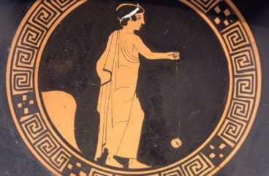
- Did you know that the Ancient Greeks invented the yoyo? The average length of string in a yoyo is 105cm.
Tom says that this is the same as 1.5m.
Betty says this is the same as 1.05m.
Kim says this is the same as 0.105m.
Who is correct? How do you know?

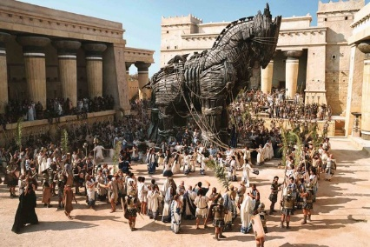
- You might have heard of the horse of Troy – this is another interesting Greek story. This event is said to have happened in 1180BC. How many years ago was this? (It might help to think of it as a negative number and you might want to use a number line to help you work it out!)

- Mount Olympus is 2,918m tall. Mount Everest is the tallest mountain in the world and is 8,848m tall. The tallest mountain in England is Scarfell Pike which is 978m.
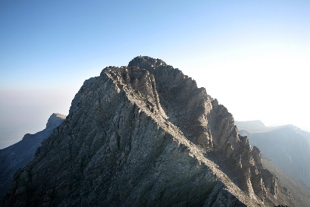
- What is the difference between the height of Mount Everest and Scarfell Pike?
- How much taller is Mount Olympus than Scarfell Pike?
- If all three mountains sat on top of each other, how tall would they be altogether? Can you convert this answer into km?

