MATHEMATICS
Activity: Have a go at this!
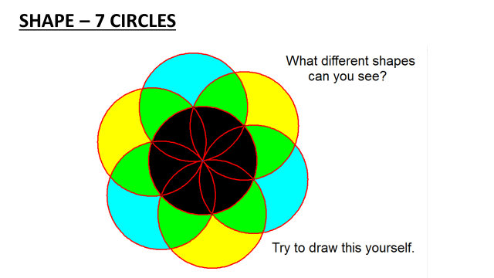
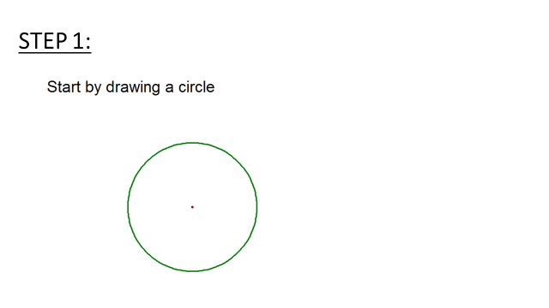

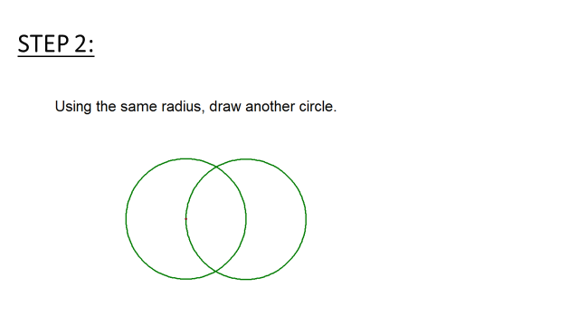

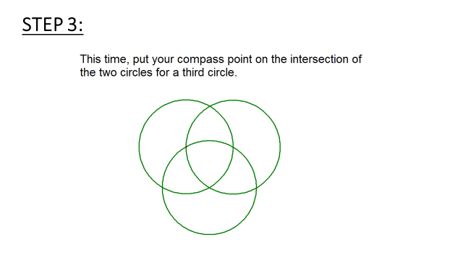

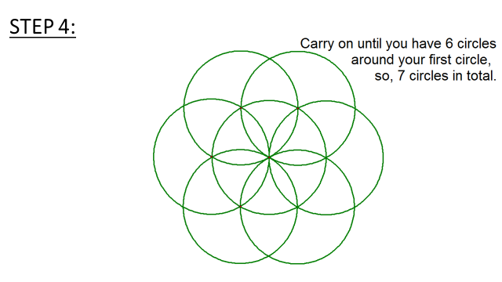

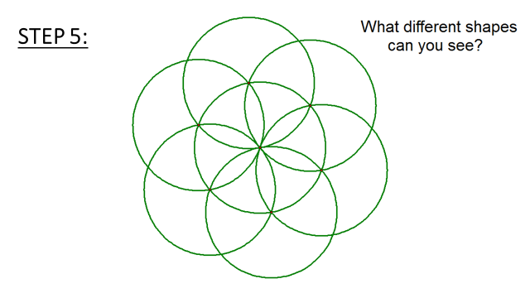

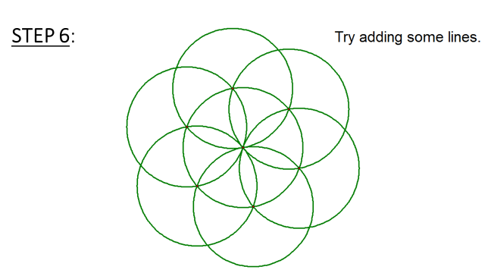

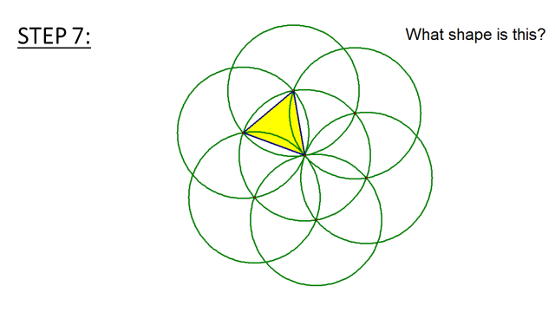
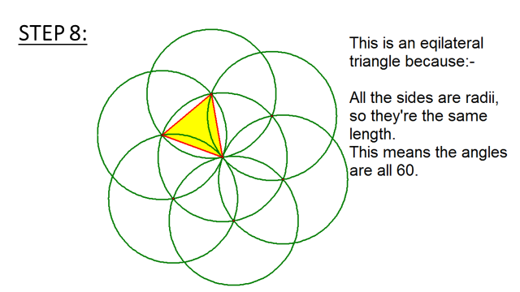

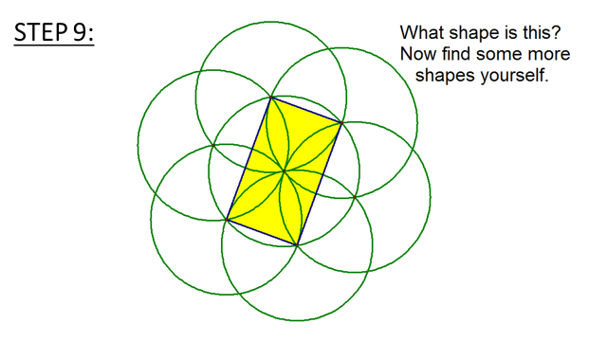

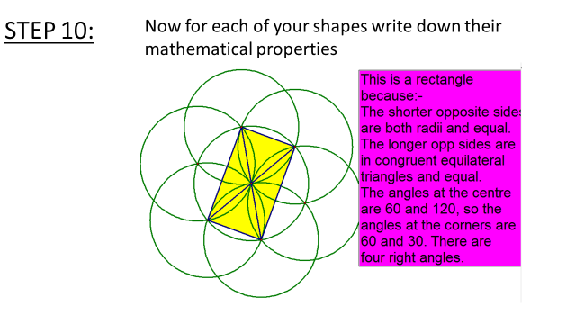

More things to do:
Reading:
Things to Make and Do in the Fourth Dimension by Matt Parker.
Matt Parker uses bizarre Klein Bottles, unimaginably small pizza slices, knots no one can untie and computers built from dominoes to reveal some of the most exotic and fascinating ideas in mathematics. Starting with simple numbers and algebra, this book goes on to deal with inconceivably big numbers in more dimensions than you ever knew existed. And always with something for you to make or do along the way.
Humble Pi: A Comedy of Maths Errors by Matt Parker.
Collection of mathematical mistakes, from bridges that wobble, millions of dollars disappearing and power failure on a passenger jet.

Websites to visit:
Numberphile- https://www.youtube.com/user/numberphile
Nrich - https://nrich.maths.org/primary
Transum - https://www.transum.org/Software/Maths_Map/

Games to play:
Two great websites with all sorts of games to play to improve number fluency
https://www.topmarks.co.uk/maths-games
https://www.educationquizzes.com/ks3/maths/

