William Blake: A Poison Tree

I was angry with my friend:
I told my wrath*, my wrath did end. * anger
I was angry with my foe:* * enemy
I told it not, my wrath did grow.
And I watered it in fears,
Night and morning with my tears;
And I sunned it with smiles,
And with soft deceitful wiles*. * tricks
And it grew both day and night,
Till it bore an apple bright.
And my foe beheld it shine.
And he knew that it was mine,
And into my garden stole
When the night had veiled* the pole; * covered
In the morning glad I see

My foe outstretched beneath the tree.


- Can I understand the surface meaning of a poem?
- Can I work out the ideas the poet might have been expressing in a poem?
- Can I use examples of the poet’s language to support my view?
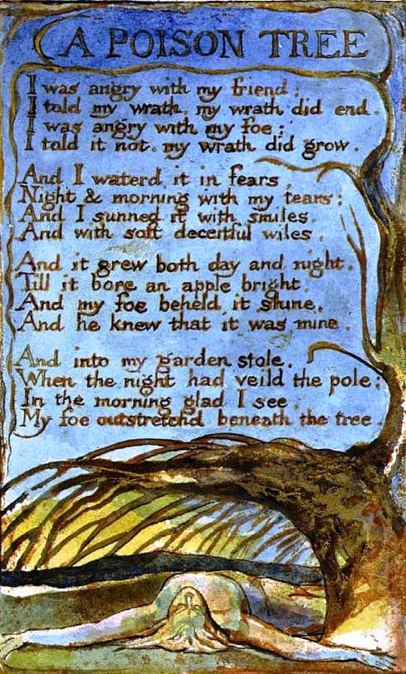

Anger
Synonyms

