Maths White Rose Resources

Go to the website:
https://whiterosemaths.com/homelearning/year-5/

It should look like this:

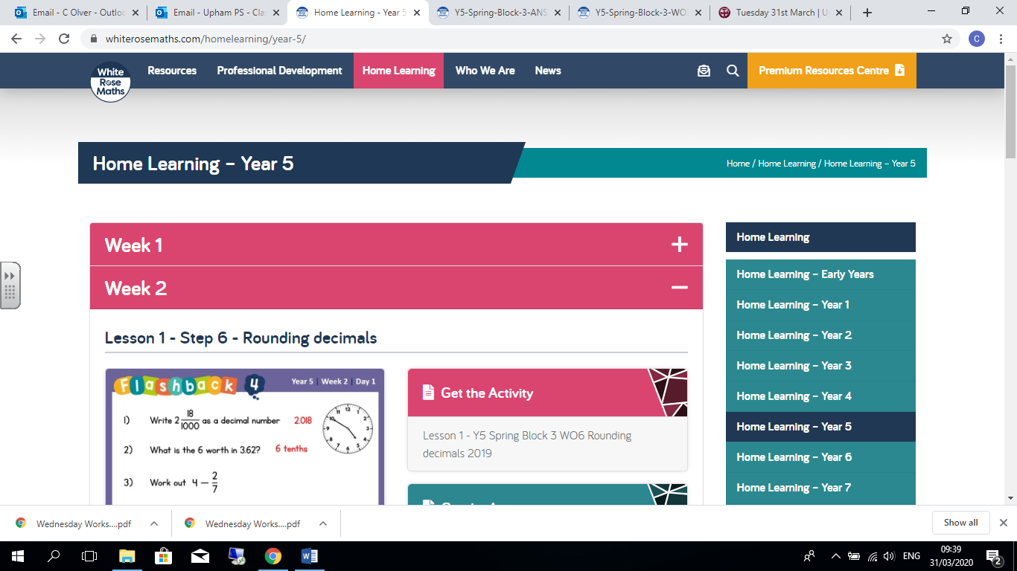

Click on the + sign at the end of Week 1

It should then drop down to open the Week 1 resources

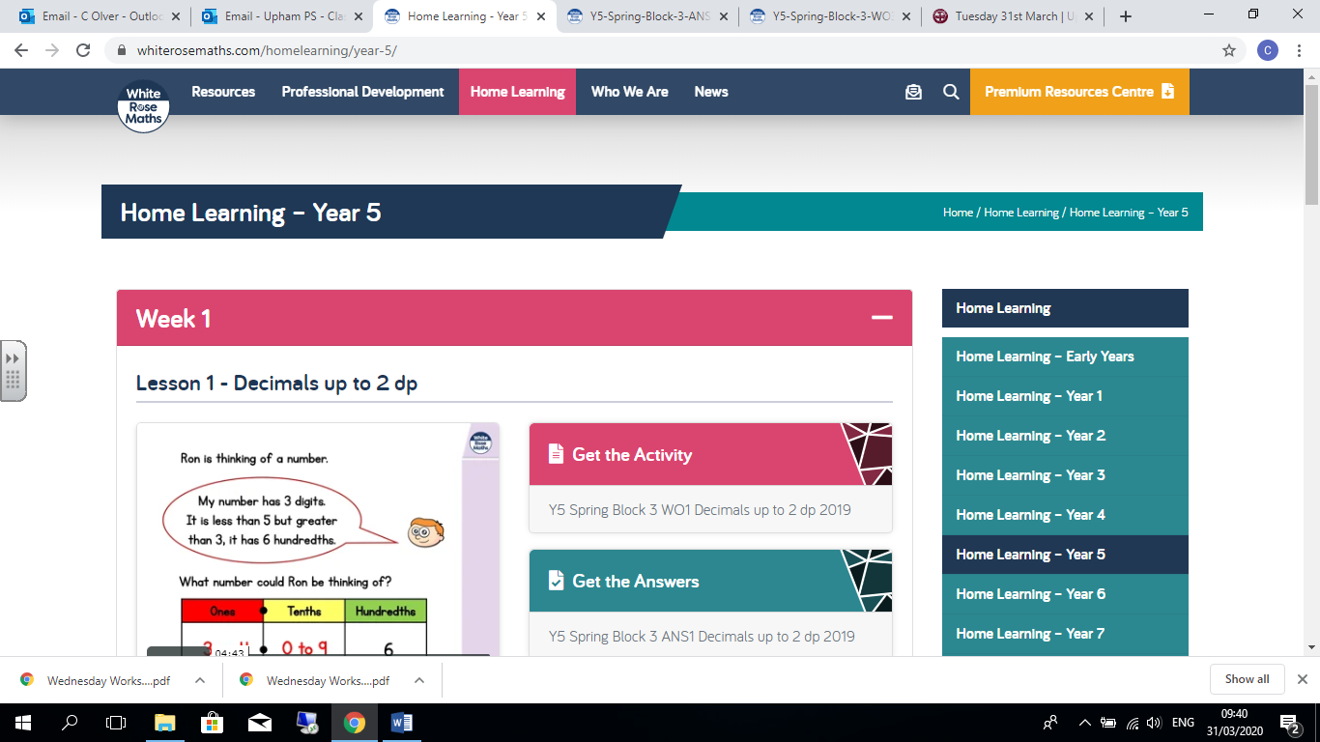

Then work through the lesson set. You can open up the worksheets and answers straight from this page, or I have saved them on our class home learning page.

