

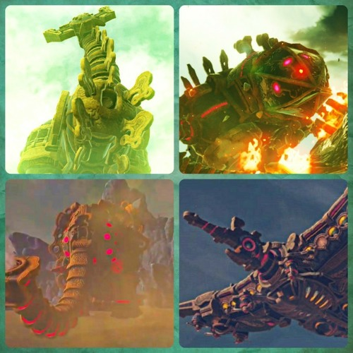
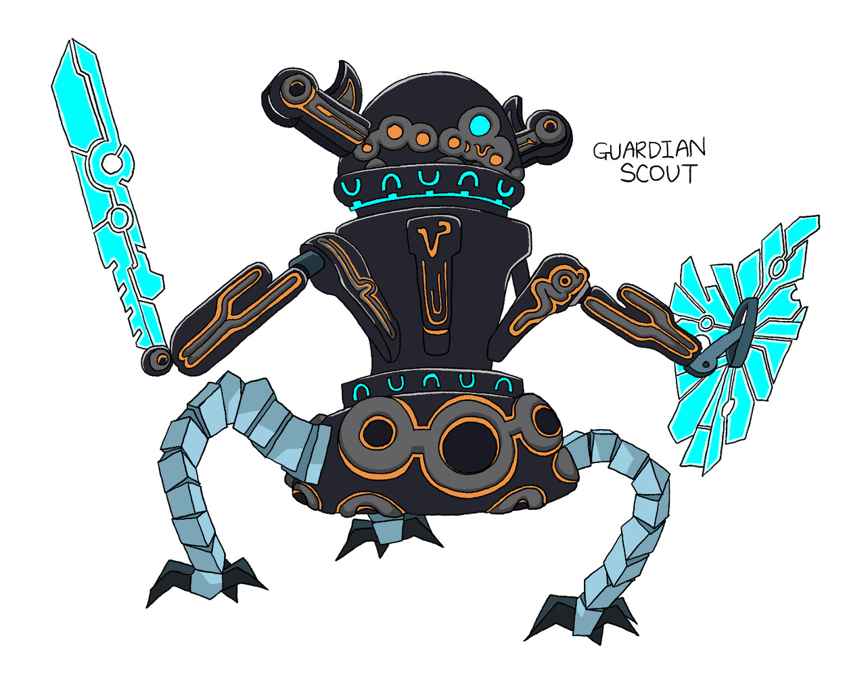
Once in the land of Hilya Link, Zelda, Robbie and I were investigating the ancient guardian scouts when we heard that the Gorons, Zora, Gerudo and Rito had all uncovered a divine beast each.

I returned home and tried to replicate the guidance stone found in the beasts. While doing so I discovered that our sheikah slate had runes with special abilities inside. These were Remote bombs, magnesis to move metal, stasis to stop time for a brief time, cycronis to make pillars of ice, and a camera. I discovered that using the guidance stone I could create new runes. I tried to make an anti- aging rune but the result was that I looked like a 6 year old and my stone stopped working because the ancient flame went out. I would have relit the flame but I couldn’t go outside and my assistant didn’t know the way but I couldn’t show him for the same reason. So we were forced to wait until someone showed up.

This we did although the wait was 100 years. Then as if by magic the person that came was Link. He had lost his memory over the years. This was a downside but he ran the errand anyways. In return I promised to upgrade his sheikah slate’ runes. And restore the missing parts
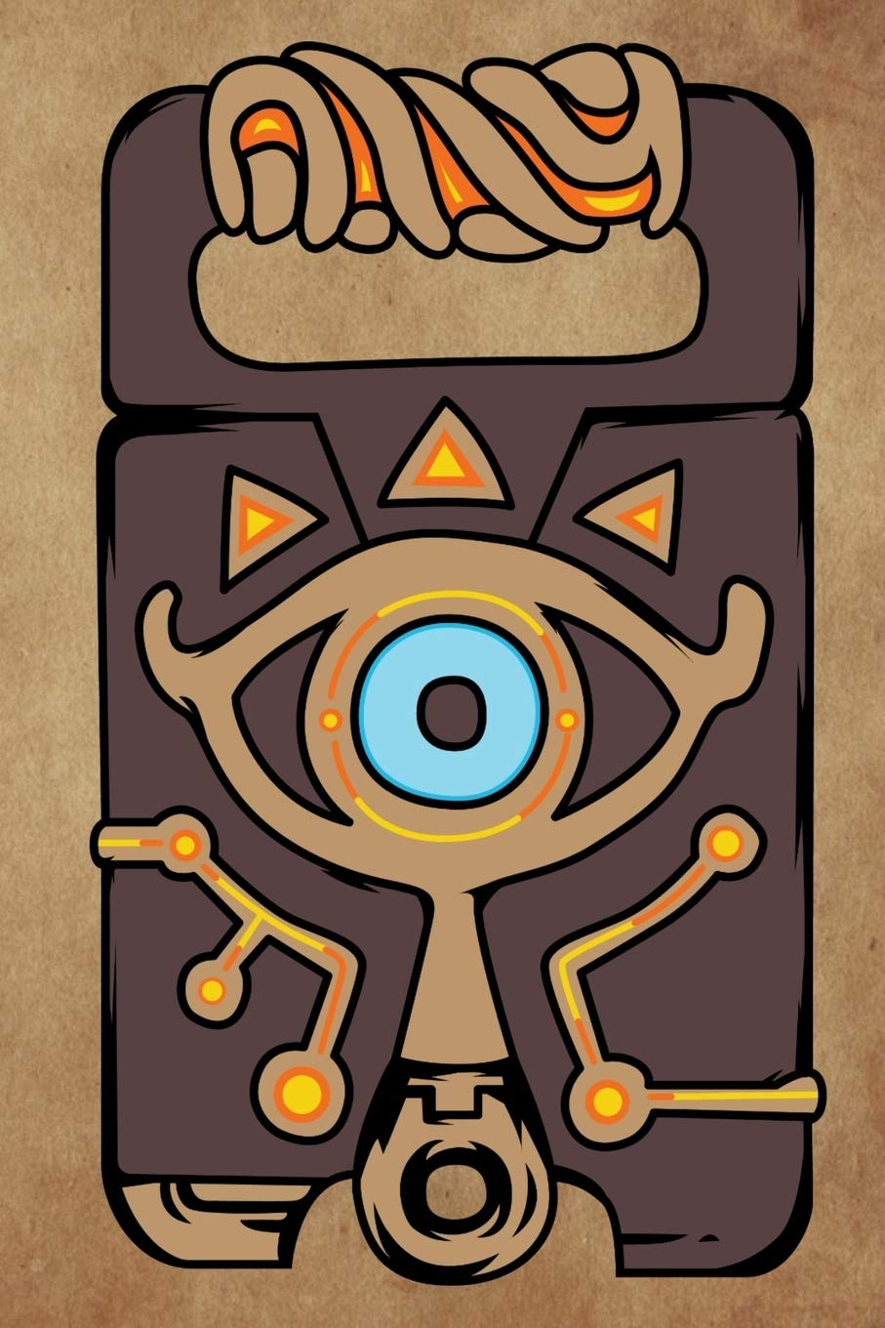
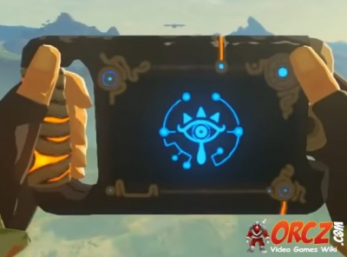
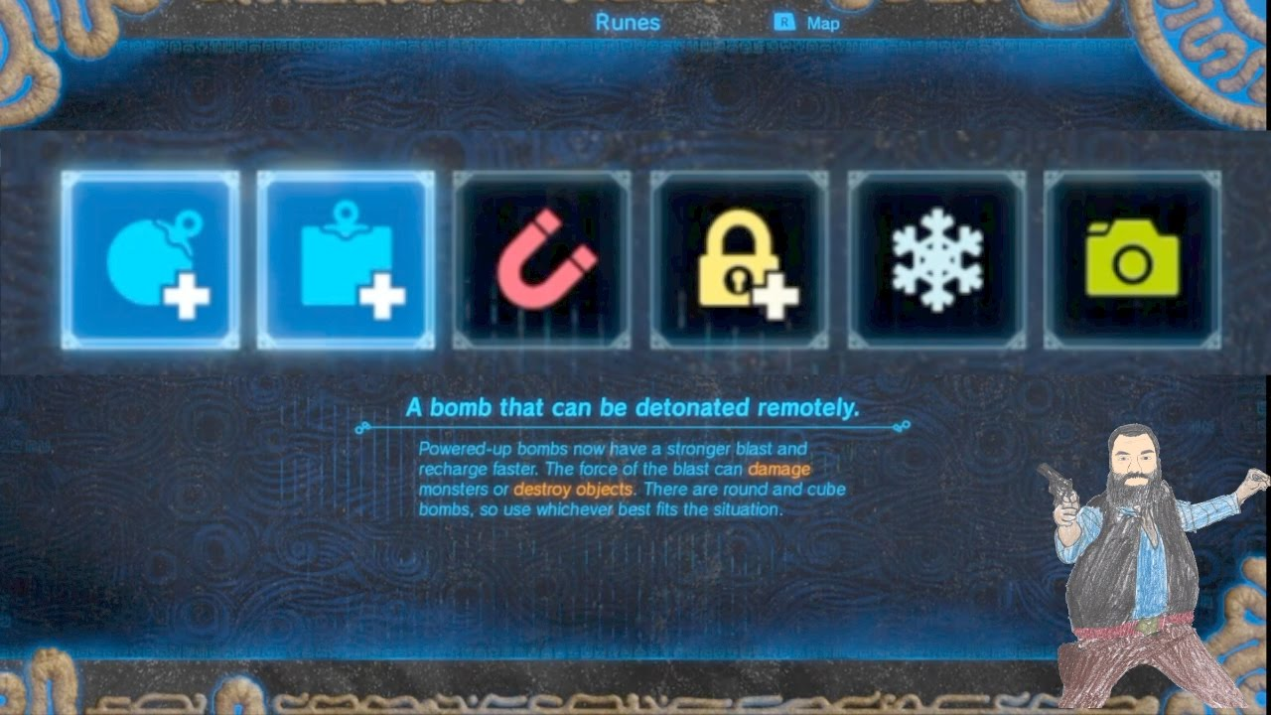

By Zac G

