Unit 1: Counting and naming numerals |  |  |  | AUTUMN Understanding Number: Unit 1, Exploring and Playing
Play Activity 1: Number hunt |  |  |  | AUTUMN Understanding Number: Unit 1, Exploring and Playing
Aims:  To find and count objects with accuracy | You will need: small shells/dinosaurs/figures/plastic animals, etc.; Number cards 1-10 (see resources) |  |  | AUTUMN Understanding Number: Unit 1, Exploring and Playing
Preparation: Bury small objects in the sand tray |  |  |  | AUTUMN Understanding Number: Unit 1, Exploring and Playing
What to do:  - Bury a number of small animals/shells/dinosaurs etc. in the sand. Place a number card visibly on the sand tray.  - Challenge children to find that number of objects.  - Once they have found them all, can they choose a number card and bury that number of objects in the sand for other children or an adult to find? |  |  | 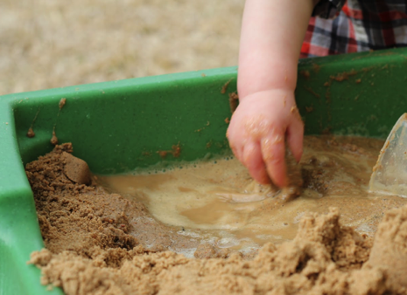 | AUTUMN Understanding Number: Unit 1, Exploring and Playing
Talking points  - How many have you found so far?  - Is that all of them? How do you know it is/isn’t?  - How many are buried in all?  - How many do you want to bury? Which card will you need to show? |  | Evidence of learning:  Listen to children talking. Are they discussing how many? Do they know when they’ve found them all?  Observe children. Do they recognise the number on the card? Can they say it and match the spoken number to the written numeral? |  | AUTUMN Understanding Number: Unit 1, Exploring and Playing
Outcomes: I can count the objects in a set.  I recognise a written number up to 6.  I know when I have found the number of objects to match a number on a card. |  |  |  | AUTUMN Understanding Number: Unit 1, Exploring and Playing

Unit 1: Counting and naming numerals |  |  | AUTUMN Understanding Number: Unit 1, Exploring and Playing
Play Activity 2: How many animals |  |  | AUTUMN Understanding Number: Unit 1, Exploring and Playing
Aims:  To count the number of objects in a set with accuracy | You will need:  small animals; animal pens |  | AUTUMN Understanding Number: Unit 1, Exploring and Playing
Preparation: None required |  |  | AUTUMN Understanding Number: Unit 1, Exploring and Playing
What to do:  - Children make pens for different toy farm animals.  - They count how many animals they have in their pen.  - Can they place a different number of animals in another pen?  - Encourage them to group animals of one type in a pen, e.g. How many cows in the cow pen? How many sheep?  - Encourage children to match one-to-one as they count. |  | 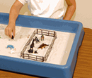 | AUTUMN Understanding Number: Unit 1, Exploring and Playing
Talking points  - How many animals in your pen? Are they all the same type?  - How many cows? How many dinosaurs?  - Are there more cows or more sheep?  - Which pen has the most animals? The fewest? | Evidence of learning:  Listen to children talking. Can they say how many in a pen? Can they say which pen has most/fewest?  Observe children. Do they count accurately by pointing at each animal as they say the number? |  | AUTUMN Understanding Number: Unit 1, Exploring and Playing
Outcomes: I can count how many in a set by matching one-to-one as I say the numbers.  I can count accurately to 6 or 10. |  |  | AUTUMN Understanding Number: Unit 1, Exploring and Playing

Unit 1: Counting and naming numerals |  |  |  | AUTUMN Understanding Number: Unit 1, Exploring and Playing
Play Activity 3: Build a brick model |  |  |  | AUTUMN Understanding Number: Unit 1, Exploring and Playing
Aims: To choose a number to match a set  To count correctly the number of bricks used | You will need: LegoTM/DuploTM; sticky notes |  |  | AUTUMN Understanding Number: Unit 1, Exploring and Playing
Preparation: Write numbers 1 to 10 clearly on sticky notes. |  |  |  | AUTUMN Understanding Number: Unit 1, Exploring and Playing
What to do:  - Provide a set number of LegoTM/DuploTM bricks, e.g. 10.  - Children make models with up to 10 bricks.  - They choose a sticky note to label how many bricks they used.  - They make a different model with a different number of bricks. |  |  | 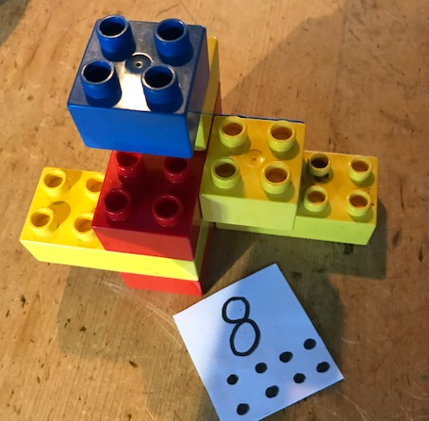 | AUTUMN Understanding Number: Unit 1, Exploring and Playing
Talking points  - How many bricks have you used so far  - Can you count all the bricks in your model? How do you know you have counted accurately?  - Can you show me how you count the bricks in your model? What strategies do you use? |  | Evidence of learning:  Listen to children talking. Can they count with accuracy, turning their model round, and making sure that they do not count any brick twice?  Observe children. Do they try to touch each brick as they count it? |  | AUTUMN Understanding Number: Unit 1, Exploring and Playing
Outcomes: I can say the numbers in order, 1 to 10.  I can count objects by matching one-to-one with the numbers spoken.  I can count objects in in irregular 3-D arrays. |  |  |  | AUTUMN Understanding Number: Unit 1, Exploring and Playing

Unit 1: Counting and naming numerals |  |  | AUTUMN Understanding Number: Unit 1, Exploring and Playing
Play Activity 4: Big bird wing flaps |  |  | AUTUMN Understanding Number: Unit 1, Exploring and Playing
Aims: To recognise a numeral  To say the numbers when counting in the correct order | You will need: chalk |  | AUTUMN Understanding Number: Unit 1, Exploring and Playing
Preparation: Chalk big numbers on the playground |  |  | AUTUMN Understanding Number: Unit 1, Exploring and Playing
What to do:  - Write really big numbers between 1 and 10 on the playground.  - Children stand on a number and choose an action to carry out that many times, e.g. jumping, hopping, clapping or turning.  - They especially love doing wing flaps like a big bird!  - Can they think of different actions to match each number? |  | 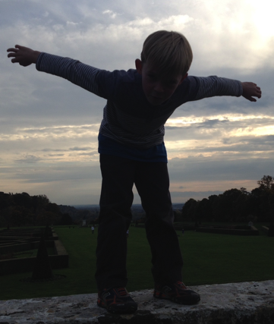 | AUTUMN Understanding Number: Unit 1, Exploring and Playing
Talking points  - How many wing-flaps should we do? Who is counting?  - What number am I standing on now? How many jumps more must I do?  - We’re on 4. Count together as we do four bunny hops. |  |  | AUTUMN Understanding Number: Unit 1, Exploring and Playing
Evidence of learning:  Listen to children talking. Can they say how many actions? Do they match each action to each spoken number in the count? Observe children. Do they count accurately? Do they say the numbers in order? How far can they count? |  |  | AUTUMN Understanding Number: Unit 1, Exploring and Playing
Outcomes: I can count actions.  I can say the numbers 1 to 10 in order. |  |  | AUTUMN Understanding Number: Unit 1, Exploring and Playing

Understanding Number Unit 1
Counting and naming numerals
Exploring and Playing
Teacher Notes

You will need:
- small shells/dinosaurs/figures/plastic animals, etc.; Number cards 1-10 (see resources); small animals; animal pens; LegoTM/DuploTM; sticky notes; chalk

KEY CONCEPTS
- Chanting the numbers in order: Children need to become absolutely secure in chanting the numbers in order from 1 to 10 and then to 20. This is best achieved by starting with a large group, where the children who cannot do this are carried along by those who can. Once children can successfully count in unison, then try them in small groups – which they may find harder.
- Counting back: Only once children are secure counting in a large group is it wise to start counting backwards from 10 to ‘Blast-off’ and then from 20 down to ‘Blast-off’. They do love doing this, especially if they are allowed to jump up to launch the rocket.
- One-to-one correspondence: It is very important that children learn to count items or objects by matching each thing to the spoken number. One (touching the first item), two (touching the second item), three (touching the third) and so on. Matching one-to-one like this helps them count with accuracy, so is an essential mathematical skill.
Watch out for children who:
- …struggle to remember the sequence of numbers
Support with more practice chanting the numbers in order, especially as part of a larger group.
- …count faster than they touch the items being counted, so do not match one-to-one and find the wrong total.
Support them by modelling how to match one-to-one when counting, insisting that they touch each item as they say the number.

