How to present your Powerpoint or Word document on Google Classroom.

Before you join Google classroom, have your document or Powerpoint open and minimised ready.
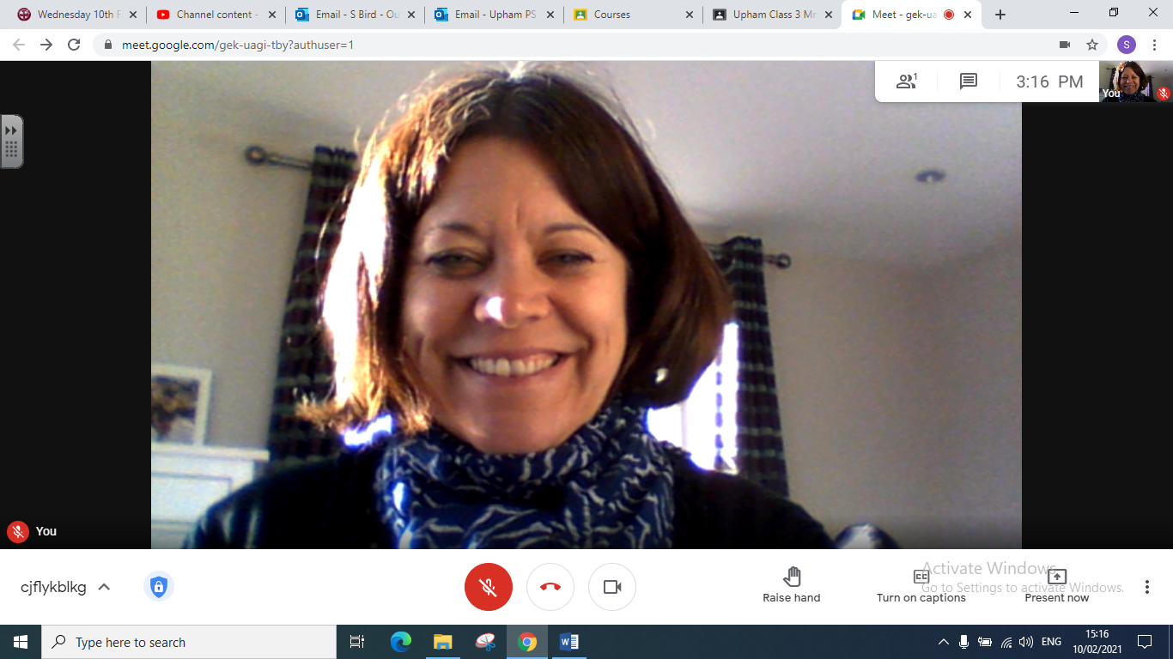

When it is your turn click on the Present now icon

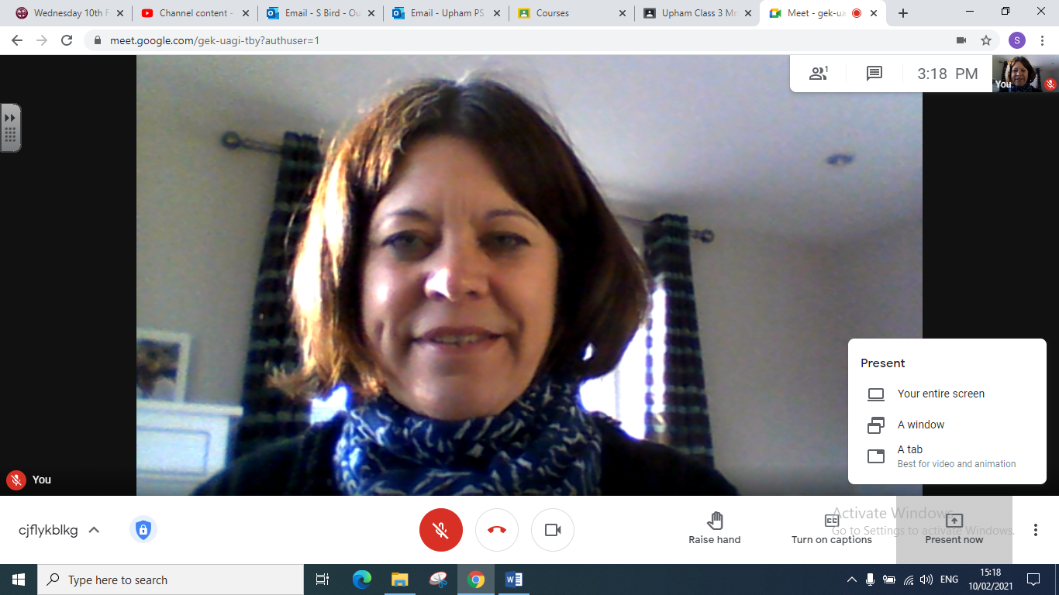 Click on Your entire screen

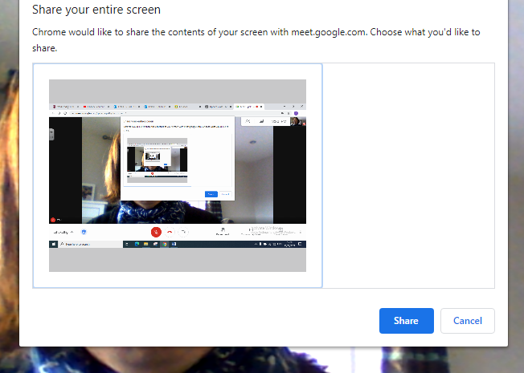
Click on the image here there press Share

You then need to maximise your Word or Powerpoint document and you will see it on your screen as below
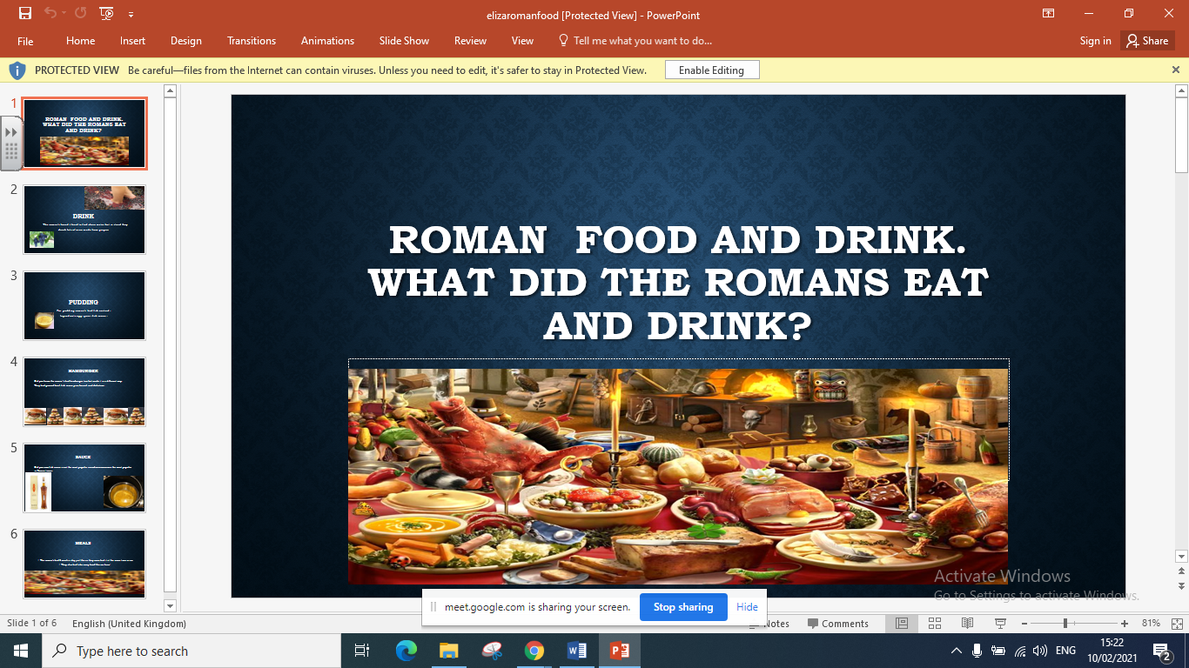

You can set up a slide show or just click along the pages at the side if you have a Powerpoint. If it is a Word document, just scroll down as you talk

When you have finished, click on the Stop Sharing icon.
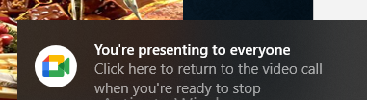
Finally Click here to return to the video call.

