Can I convert analogue and digital time using 12 hour clock (minutes past)?
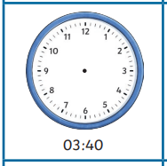
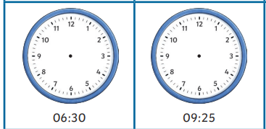
Draw the time on the clock faces
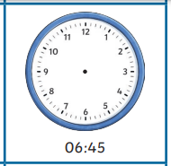
Digital time | Analogue time in words
11:15 | ___________ minutes past ____________
 | 23 minutes past 3
8:27
 | 4 minutes past 7
12:40
 | 10 minutes to 5
1:38
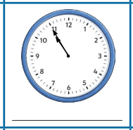
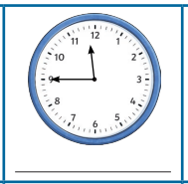
Write the digital time under the clock


