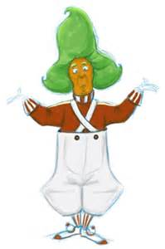
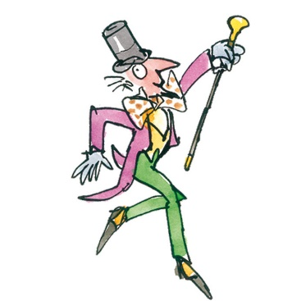
Can I sort materials into solids and liquids?
Oh no! The Oompa Loompas have muddled all the ingredients in Mr Wonka’s chocolate factory. The ingredients need to be put in either the solids machine or the liquids machine. Can you help sort all the foods you find around the factory and put them in the correct machine?
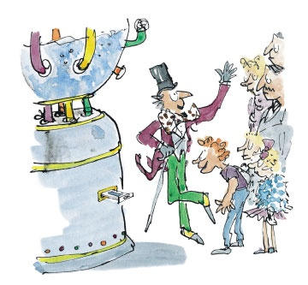  Solids | Liquids | Tricky ones

