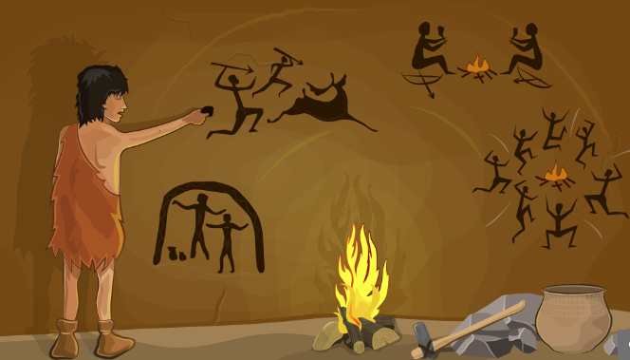

Can I find out about life in the Stone Age?

Click to go to the website below. Watch the video to find out how we know about the Stone Age and how tools and weapons were made.
https://www.bbc.co.uk/bitesize/topics/z82hsbk/articles/z34djxs

Explore this picture of an imaginary boy called Grey Otter. Label the picture to show what you found out.

