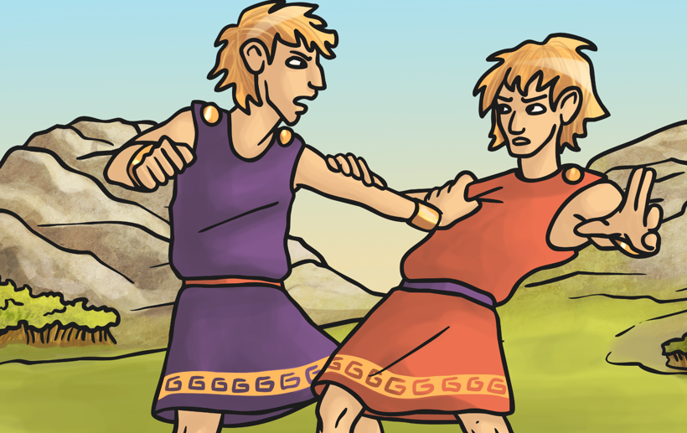
The Story of Romulus and Remus

Number the events in the order they come in the story:
The servant puts the twins in the river.
Romulus kills Remus in a fight.
The boys are offered to be joint kings of Alba Longa
Amulius becomes king.

Do you think the servant of Amulius did the right thing? Explain why.
Who rescued the twins from the river? Who brought them up?
How would you describe Romulus and Remus?
What did the brothers agree on and what did they disagree on?
In the end, why did only one brother build the city?
What was the name of the Hill the city was built on?
What event does this legend explain?

