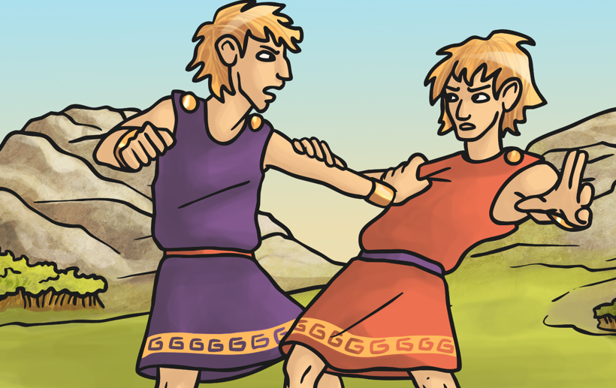
The Story of Romulus and Remus

Number the events in the order they come in the story:
The servant puts the twins in the river. 2
Romulus kills Remus in a fight. 4
The boys are offered to be joint kings of Alba Longa 3
Amulius becomes king. 1

Do you think the servant of Amulius did the right thing? Explain why. Give own opinion
Eg
Yes he did the right thing because he didn’t want to harm the innocent twins.
No because the servant should have followed the orders he was given.
Who rescued the twins from the river? A she-wolf rescued the twins from the river.
Who brought them up? A shepherd and his wife brought up the twins
How would you describe Romulus and Remus? They were argumentative, competitive and unkind
What did the brothers agree on and what did they disagree on?
They agreed that they should build a city but they didn’t agree on which hill to build it on. They also disagreed about who saw the most vultures.
In the end, why did only one brother build the city? Only Romulus built the city because he killed his brother Remus.
What was the name of the Hill the city was built on?
The hill the city was built on was called Palantine Hill.
What event does this legend explain?
The legend explains how the city of Rome was started.

