Romulus and Remus
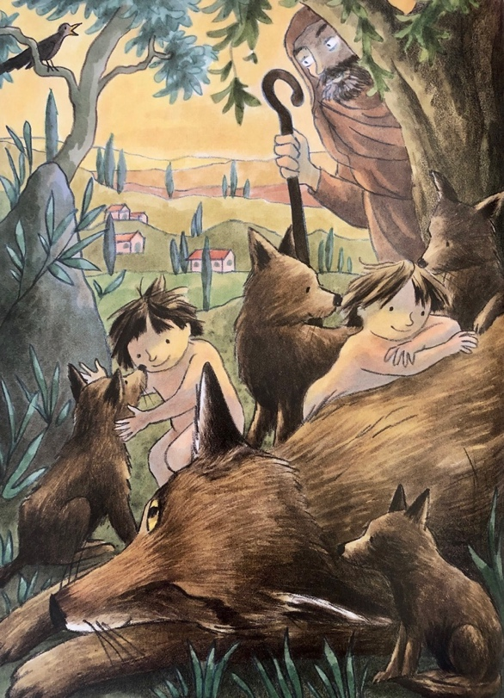

Romulus and Remus were sons of the god Mars. As babies they were thrown in the river Tiber and were rescued by a wolf. She cared for them, until they were found and adopted by a shepherd.

Romulus and Remus grew up into brave, quarrelsome boys who never shunned a fight and who never lost one either.
No shepherd life for them! Even before they were told the story of their birth, they were roaring boys, with roaring friends, their sights pinned on glory. They set their hearts on building a new city, a grand city, a city to rival Troy or Carthage or Athens.
"It shall be called Reme," said Remus.
"Rome, you mean," Romulus corrected him. They quarrelled about it, naturally; it was their way to squabble and row. Brothers do.
But where was their magnificent city to be built?
"Here," said Romulus.
“No over there, near that clump of trees," replied Remus.
"Never!" They squabbled and rowed. Brothers do. The gods looked on with mild amusement.
"Let the gods decide!" said Romulus.
"Yes, we'll watch for a sign," agreed Remus. The gods, too, nodded agreement, and Jupiter sent a flock of ravens to mark the spot fixed by Destiny for the building of the sacred city.

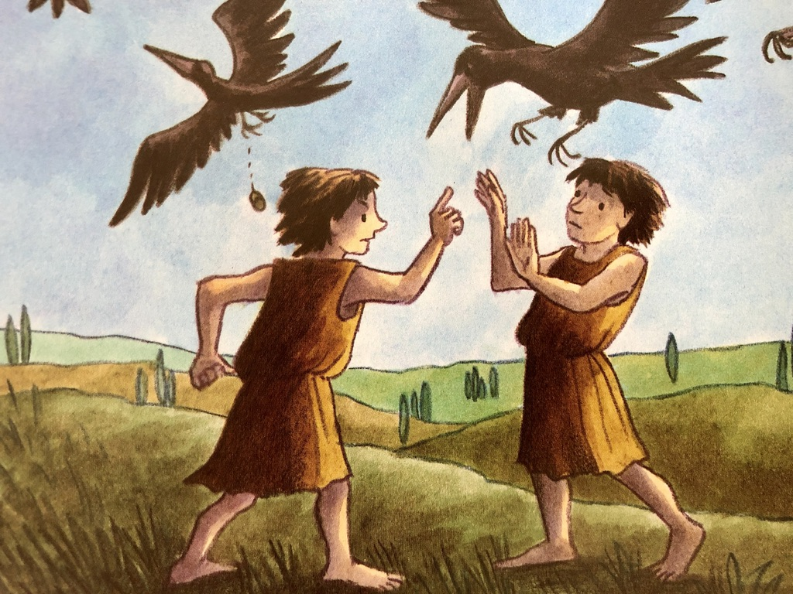

"There! There! Look, three ravens!" cried Remus. "The sacred birds of Jupiter!"
An acorn dropped from the claw of one bird and fell to earth. The brothers, however, were too busy arguing to notice where it fell.
"Seven ravens. There were seven not three," said Romulus.
"What does it matter? I saw them first. So, I choose where Reme is built."
"But I saw more ravens than you!" protested Romulus. "So I shall build in my chosen place. You can do as you like ... and it will be Rome, not Reme!" They exchanged a string of insults. Brothers do. The gods frowned a little at their squabbling. Time was going to waste.
Obstinate Romulus, began to build - where the Tiber snaked between seven hills, where the sunbeams were blade-sharp and golden, and between the stones were mossy massive — heaping the boulders into a wall.
"Call that a wall?" jeered Remus. "I've seen bigger pigsties!" and he jumped over the low walling, his feet dislodging pebbles, his taunts loud and sneering. To and fro he jumped, deriding Romulus's work until all brotherly affection dissolved in Romulus and he hated his brother with a hot loathing. Brothers can. He picked up a boulder. "You do that once more...”
Remus jumped the wall. A whole section slumped down in a landslide of rocks and pebbles. Romulus lifted the boulder and brought it down on his brother's head. Remus was dead before he even hit the ground. "Thus die all those who ever try to leap the walls of Rome!" Romulus crowed, as his young warrior friends ran to the spot and crowded round.
Then Romulus wept, because he had killed his best friend in the world, and all for the sake of a pile of stones.

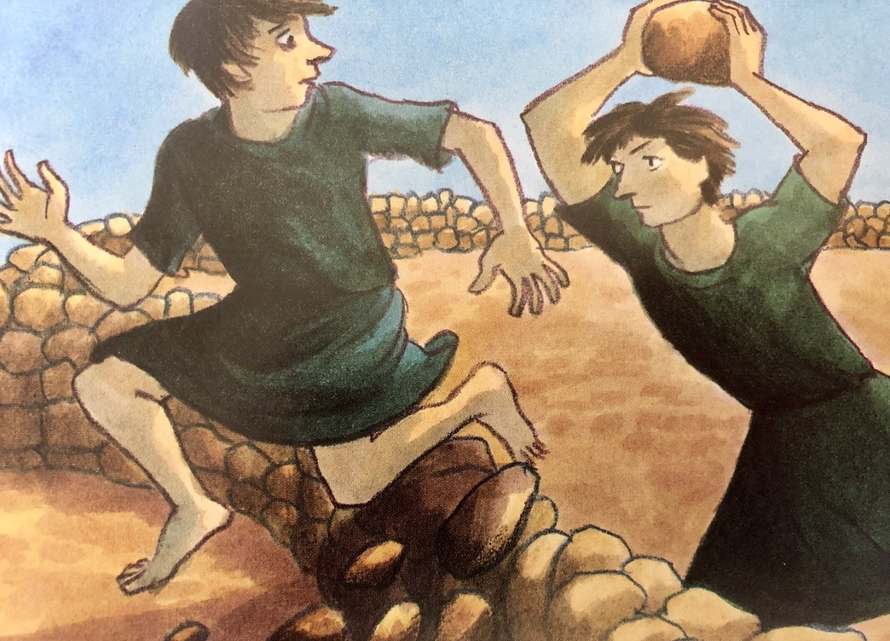
The gods looked on with distaste. How could the destiny of an empire rest on the shoulders of such men?
“It is good," said Mars, dry-eyed, stony-faced. "It is good that blood should water the foundations of Rome."
But Jupiter shook his head. "They were fools to quarrel," he said.
"Their foolishness does not stop there," said Venus softly. "Look at them. An army of men building a city for themselves. How can there be a city without women? Where do they hope to find sons and daughters - floating on the Tiber or crying among the wolves?"

