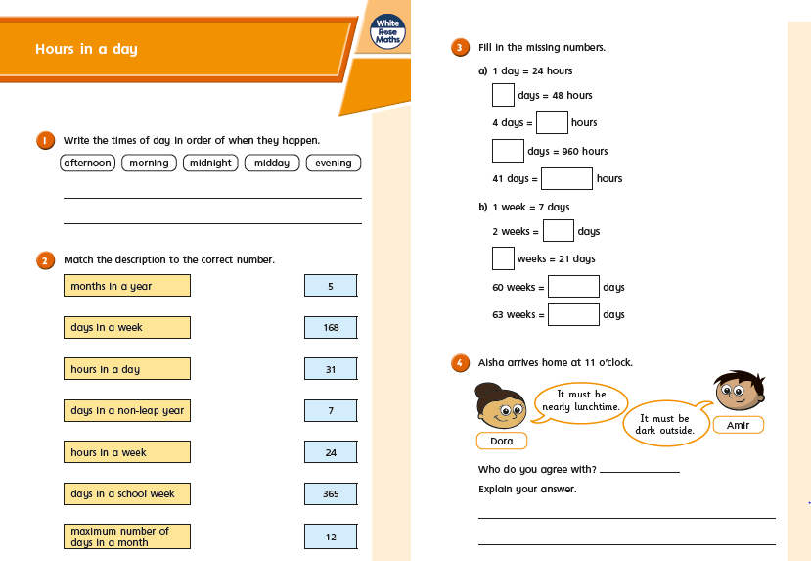
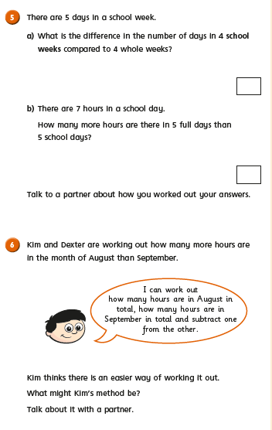
Challenge

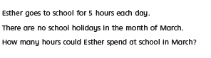
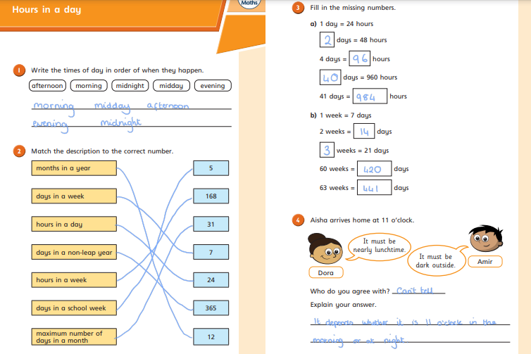
Answers

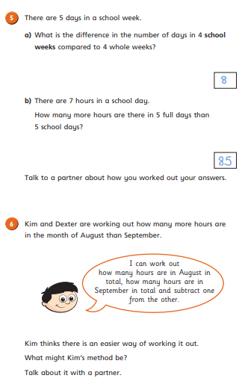
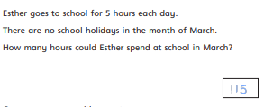
There are 31 days in March. School is 5 days a week. If the first day of March is
Monday, there will be 23 week days. (I started at 1st counted up to 5th, then 6th 7th are weekend days and so on.)

23 x 5 = 115

This is very tricky so I will be very impressed if anyone got this!!
An easier method is to find how many more
days in August than September (31 – 30=1)
Then how many hours 1x24 hours

