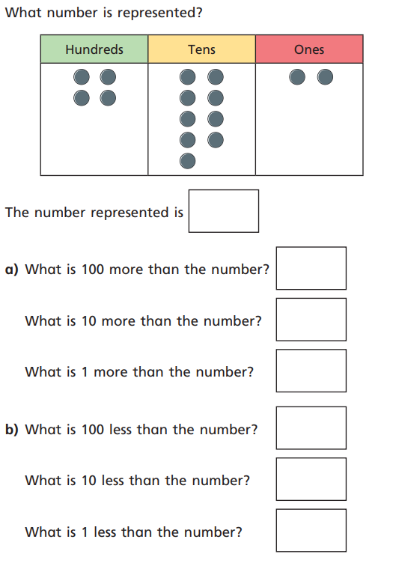
Can I add or subtract 1, 10 , 100 to a number without crossing a boundary?
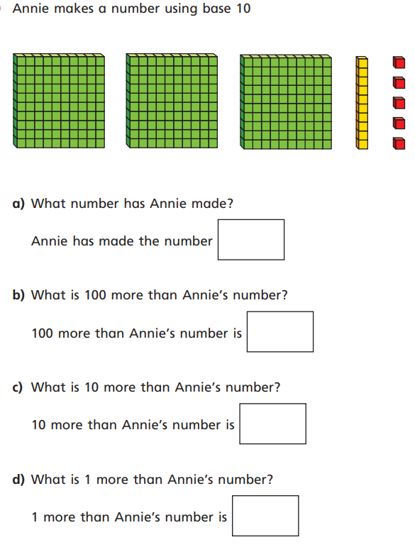

Write number sentences to find 1 more and 1 less than these numbers:
14 153 874

Write number sentences to find 10 more and 10 less than these numbers:
67 284 730

Write number sentences to find 100 more and 100 less than these numbers:
356 230 852



