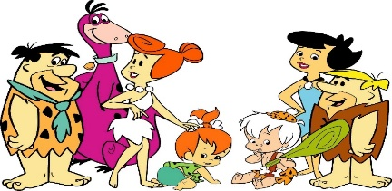
Can I ask questions about the past?
How accurate is the Flintstones cartoon? https://www.youtube.com/watch?v=3s-MnvKIqb8

In the cartoon | My questions | What I found out
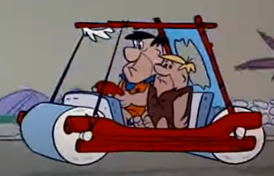 | How did they travel ?
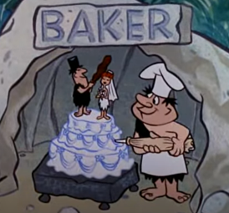 | How did they get their food?
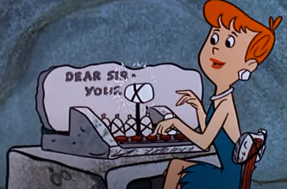 | How did they communicate?
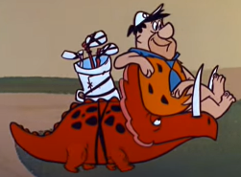 | What did they do in their spare time?
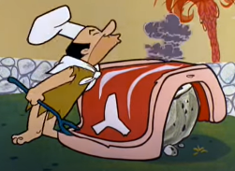 | What did they eat?  How did they cook their food?
Your own question

