Can I identify and name common rocks?
Chalk
A light coloured rock (often pale grey or cream) It has a grainy texture and may feel crumbly.
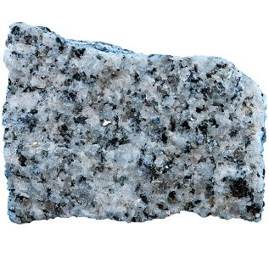

A pale cream or white hard rock that has lines running through it
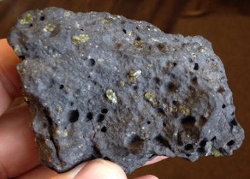

A brown or golden coloured rock with grains inside it. If rubbed grains may come away
Slate

Can I identify and name common rocks?
Chalk
Limestone | A light coloured rock (often pale grey or cream) It has a grainy texture and may feel crumbly.
Granite
Marble | A hard rock that has lines or speckled colours in it.
Basalt
Sandstone | A brown or golden coloured rock with grains inside it. If rubbed grains may come away
Slate

