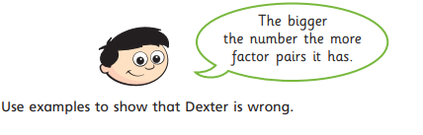
Challenge

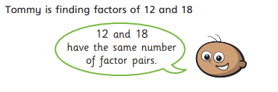

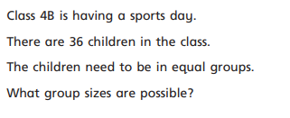

Answers
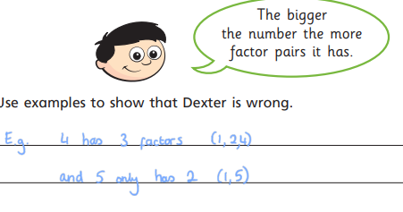

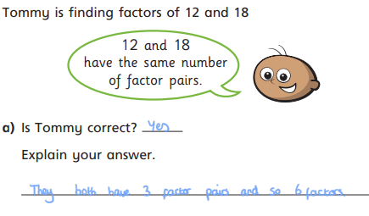
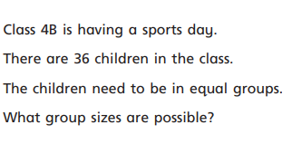

1 group of 36 2 groups of 18 3 groups of 12 4 groups of 9
36 groups of 1 18 groups of 2 12 groups of3 9 groups of 4 6 groups of 6

