The Oak and the Linden Tree Opening

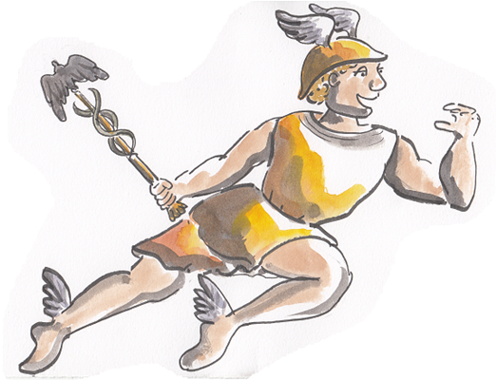
Everything was perfect on Mount Olympus. But Jupiter, the king of the gods, was bored. “Mercury!” Jupiter thundered, calling his favourite son. He thought Mercury was the most entertaining and clever of all the gods. Mercury flew to Jupiter’s side as quickly as his winged sandals could carry him. “Come with me down to Earth. We’re going to test the kindness of the people of Phrygia to see if they are worthy of my special protection,” Jupiter told him.
The two gods dressed like poor travellers and wandered through the land. Together they knocked at the doors of hundreds of homes, both grand and poor. “Please, could you give us a crust of bread or a drop of water?” Jupiter asked.
“May we have a place to rest our feet?” Mercury begged.
The people of Phrygia slammed doors in their faces. Jupiter was angry. “Let’s try one more home,” Jupiter said, “or I shall have to take my revenge.”

They came upon a tiny hut with a rickety roof of reeds. It was the poorest and smallest home that they had found. In fact, it was so small and poor that it could hardly be called a house at all. In the garden there was one scrawny cabbage. In the yard there was one bony goose. “Father, the people of Phrygia refused us at grand homes. They refused us at small homes. The people of this house have barely enough to keep themselves alive,” Mercury said.
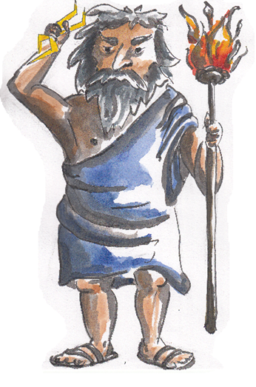
“All the same, we will give this house a try,” Jupiter told him. Jupiter limped up the crumbling steps and knocked on the door. The door opened wide. Inside were a kind-faced old man named Philemon and a lively, smiling old woman named Baucis.
“Come in!” Philemon said. “You look as though you’ve journeyed long.” Philemon brought pillows and benches for the travellers to sit beside the hearth. Baucis gave them her softest blanket to cover them.
“You are very kind to go to so much trouble,” Jupiter said.
“No trouble at all,” Baucis said as she bustled about the cottage. Jupiter watched carefully as Baucis used the last bit of wood to make a warm, crackling fire.

Questions
Answer the questions in full sentences. Remember to look back at the text when trying to answer.

- How can we tell that Philemon and Baucis are poor?
- What does the word ‘bustled’ mean? What does it tell us about Baucis?

- Why do you think Philemon and Baucis were so kind to Jupiter and Mercury?
- What do you think Jupiter is thinking when he sees Baucis use the last bit of wood on the fire?
- What do you think Philemon and Baucis will offer Jupiter and Mercury next?

Answers
- How can we tell that Philemon and Baucis are poor?
You can tell they are poor because their house is very small and they just have one scrawny cabbage and a bony goose.
- What does the word ‘bustled’ mean? What does it tell us about Baucis? Bustled means to move around quickly. It shows that she is very busy.
- Why do you think Philemon and Baucis were so kind to Jupiter and Mercury? I think they were kind because they liked to help other people.
- What do you think Jupiter is thinking when he sees Baucis use the last bit of wood on the fire? Jupiter is probably thinking that they are very generous to use up the last of their wood.
- What do you think Philemon and Baucis will offer Jupiter and Mercury next? Own ideas

