Can I multiply a 2 digit number by a 1 digit number
These are the questions from the video for you to solve using a partitioning method:
5 x 22
5 x 35
34 x 3
18 x 3
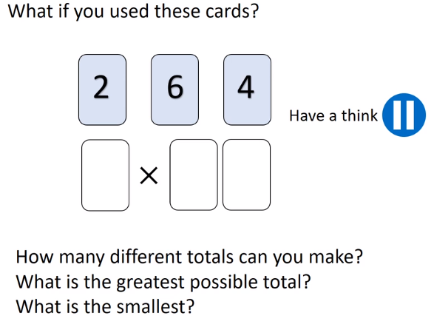
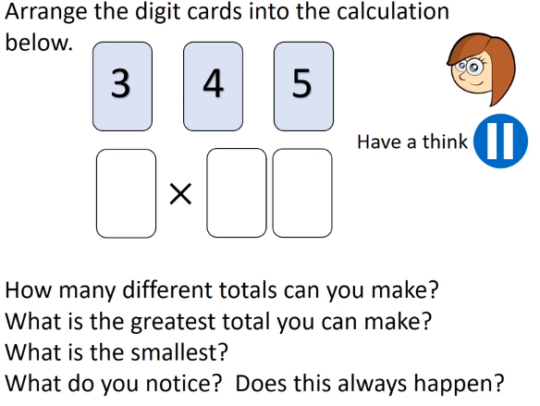
Write these in a book. Draw pictures of place value countersor Dienes if that is helpful.



