Reasoning problems
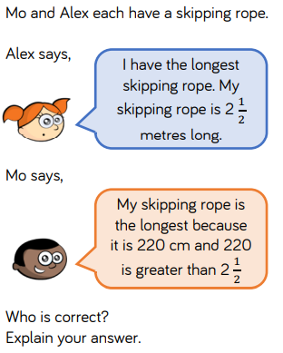

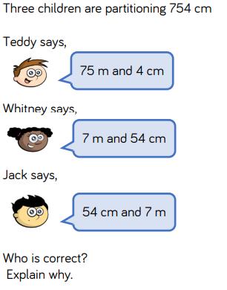

Challenge
Measure everyone in your family. Write their heights in cm and convert to m and cm. Arrange these in order from tallest to shortest

Answers


