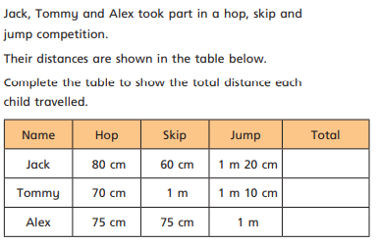
Can I solve problems involving length?

How much longer was Jack’s jump compared to his skip?
What’s the difference between the longest jump and the shortest hop?
If Jack did 3 hops, 2 skips and a jump how far did he travel in total?

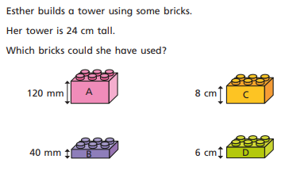
How many different solutions can you find?

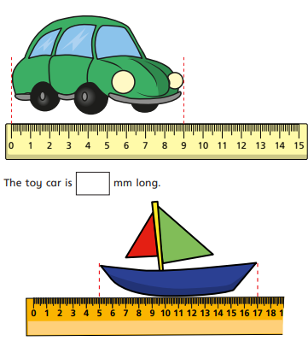
What is the total length of the car and the boat? (Be careful when you look at the boat!)

What is the difference in length of the boat and the car? Give your answers in mm





