Can I convert digital and analogue times?

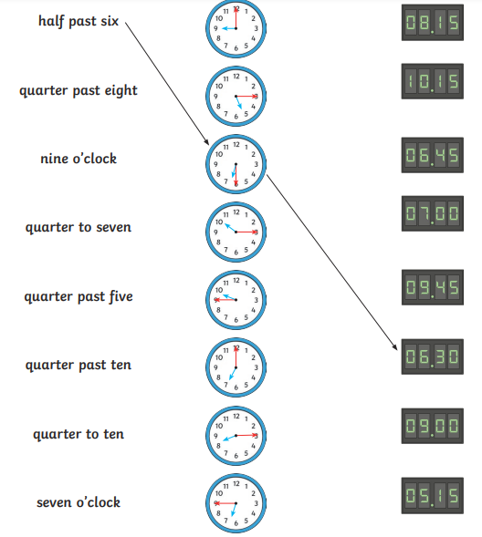
Analogue | 12 hour digital
20 to 3 in the afternoon

 | 6:50pm
 | 9:45am
20 minutes to 3 at night

25 minutes to 6 in the morning
 | 4:50 pm

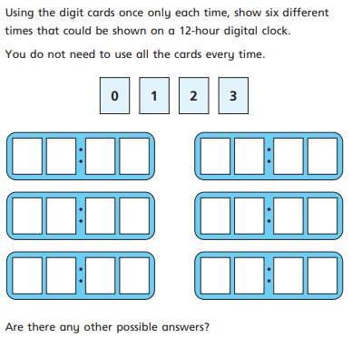
Challenge

