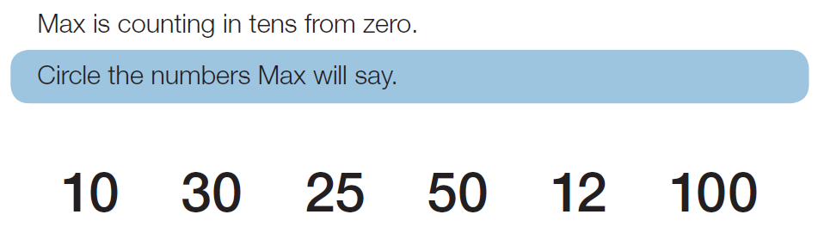

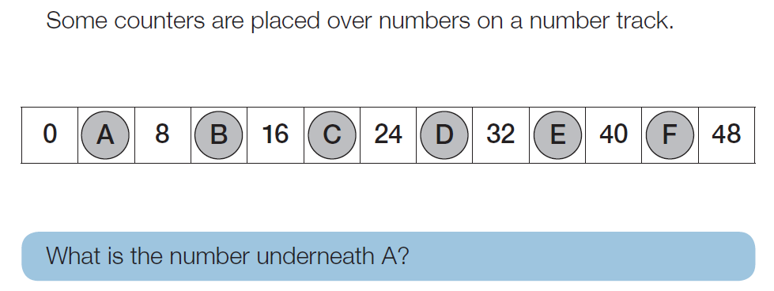





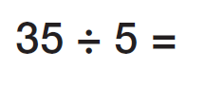

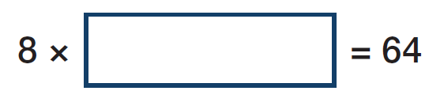

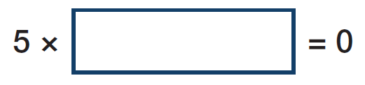

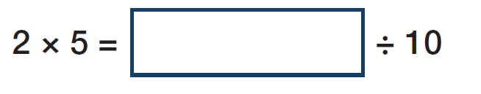
Danny had 15 lollies. He shared them between 3 friends. How many did they each get?

Sarah saved £10 per week. She wants a toy which costs £50. How many weeks will she need to save to buy the toy?
A plant was 15 cm tall. Each month it grew 3cm. After 4 months how tall was it in total?
George buys 8 packs of sweets. Each pack contains 3 sweets. He shared them between 6 friends. How many sweets do they each get?



