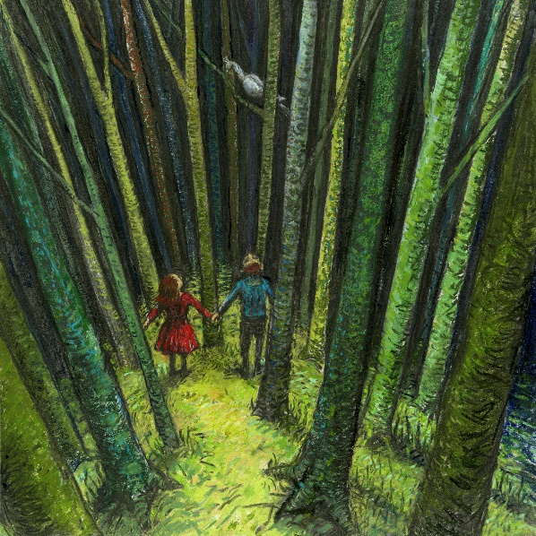
Thursday 21st January 2021
I can ask and answer questions about the story of Hansel and Gretel.

When Hansel and Gretel were alone in the forest, how did they feel?

