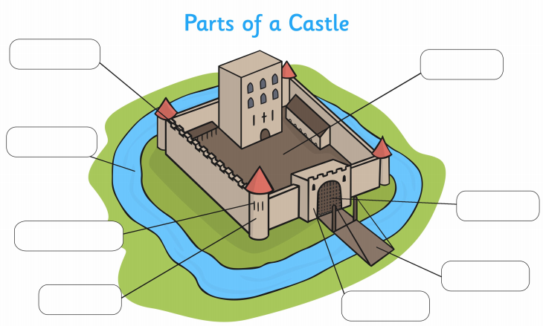
Castle parts to label the diagram:
Battlements
Bailey
Moat
Drawbridge
Portcullis
Tower
Arrow loops
Barbican

