You have 30 counters.
How many equal groups can you make?
Represent your groups as a number sentence.

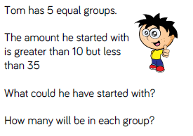

Chocolate biscuits come in packs (groups) of 5.
Sally wants to buy 20 biscuits in total.
How many packs will she need to buy?

Write this as a division number sentence.



