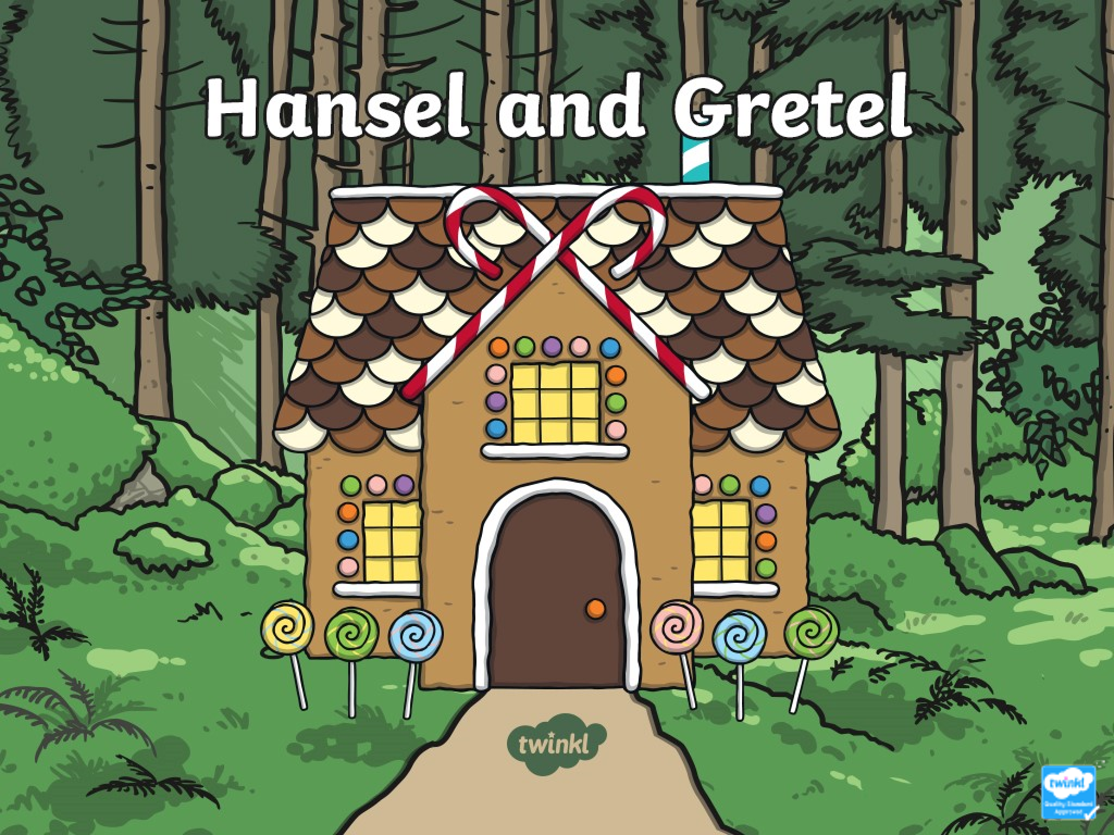

Monday 1st February 2021
I can retell the story of Hansel and Gretel.

