1.3.21: I can describe a village in Kenya and a village in the UK.

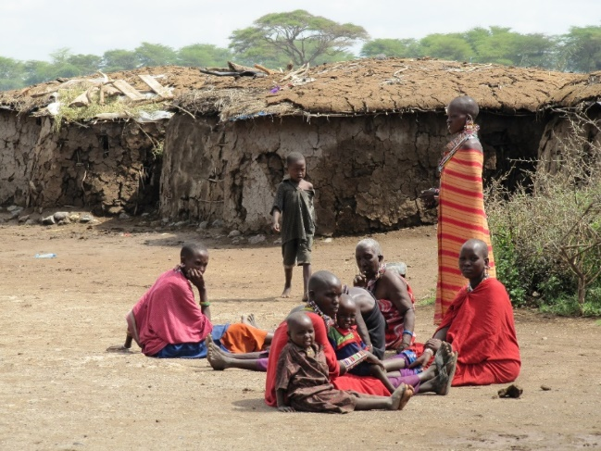
Write 3 sentences to describe the setting of the Kenyan village. What can you see?

___________________________________________________________

___________________________________________________________

___________________________________________________________

___________________________________________________________

___________________________________________________________

___________________________________________________________

___________________________________________________________

Write 3 sentences to describe the setting of the UK village.
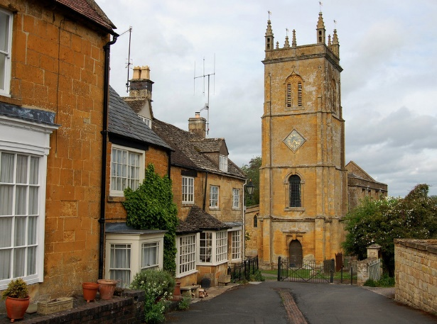
What can you see?

___________________________________________________________

___________________________________________________________

___________________________________________________________

___________________________________________________________

___________________________________________________________

___________________________________________________________

___________________________________________________________

