1.3.21: I can compare a village in Kenya and a village in the UK.

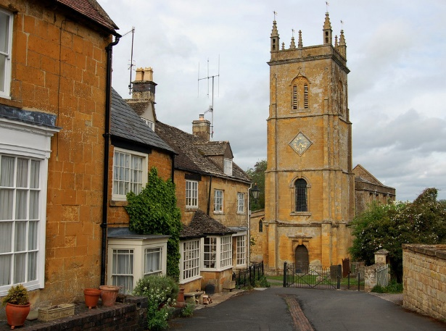
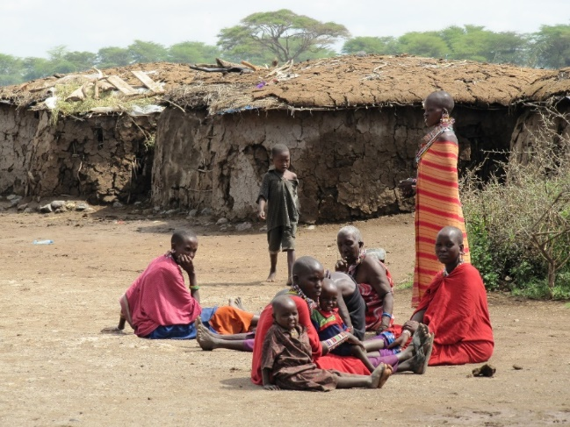

Describe each of the villages. What can you see?
What is similar and different about the two villages?

___________________________________________________________

___________________________________________________________

___________________________________________________________

___________________________________________________________

___________________________________________________________

___________________________________________________________

___________________________________________________________

___________________________________________________________

___________________________________________________________

___________________________________________________________

___________________________________________________________

___________________________________________________________

___________________________________________________________

